` 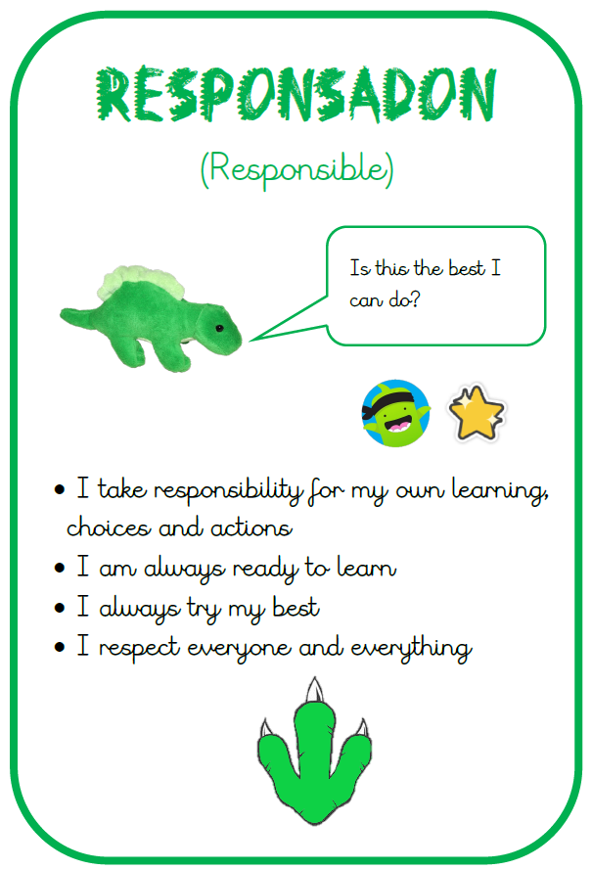
gr
Year 5 pupils will have the opportunity to take part in an exciting workshop delivered by Into University on 13th May. Into University supports young people to raise aspirations and develop confidence through engaging, age-appropriate activities. The workshop will introduce pupils to learning beyond primary school, encourage positive attitudes towards education and help them develop key skills for the future. This session will take place during the school day and all pupils will be involved.

This UKS2 Summer B topic explores the enquiry question “Do the Ancient Greeks still live on?” through a cross-curricular study of Ancient Greece. Pupils begin with a Greek Day and geographical learning about modern Greece before developing chronological understanding of Ancient Greece and its city-states. They explore daily life in Athens and Sparta, Greek religion, myths and their lessons, democracy and the Olympics. Pupils study Alexander the Great’s legacy and experience Greek culture through design technology by designing and making moussaka. The unit concludes with an art project creating decorated vases inspired by Greek design, celebrating learning through practical and creative outcomes.

Summer Term 2026

- 4th May – Bank Holiday
- 8th May – Year 6 Leavers Photos
- 11th – 14th May – SATS
- 13th May – Year 5 Into University Workshop
- 25th -29th May – Half Term
- 25th June – Summer Fair
- 10th July – Finish for Summer Holidays

- School opens at 8:40am and the school day finishes at 3:15pm. Please fill out an ‘end of day arrangements form’ with the office if there have been any changes.

- PE:
Tolerance – Monday
Liberty and Community – Wednesdays.

- Year 6 still need to continue to work through revision guides up until SATs. These need to be brought to school at least once per week.
School gates open at 8:35 am and your child should be in class by 8.45

P.E. kit needs to be worn from home on the day your child has P.E a gentle reminder the PE uniform is : Plain black , blue or grey jogging bottoms or shorts and plain white or black t-shirt. A change of shoes is also necessary. No logos or football kits should be worn.

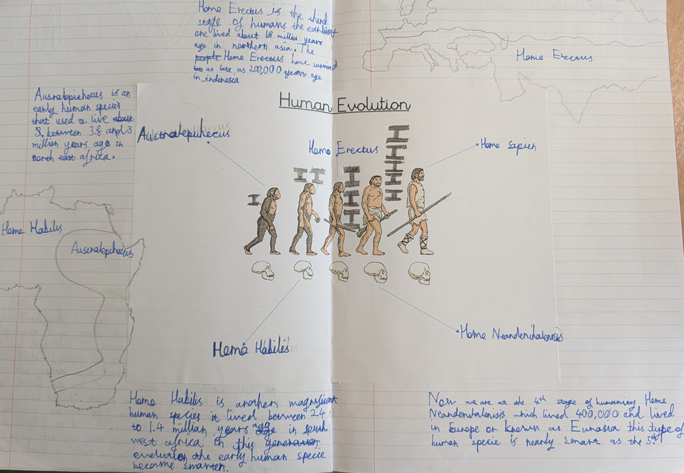
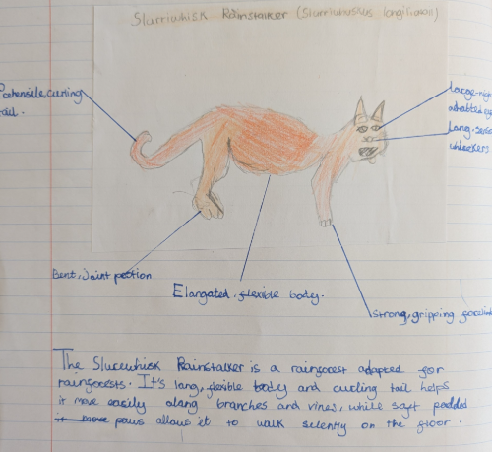
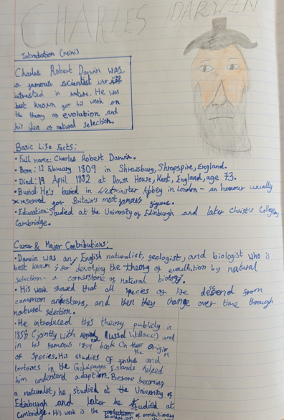
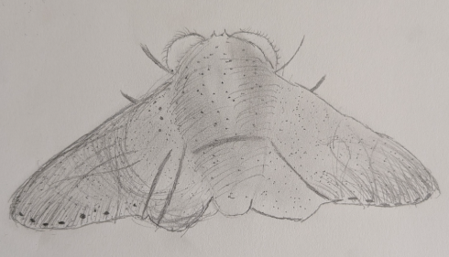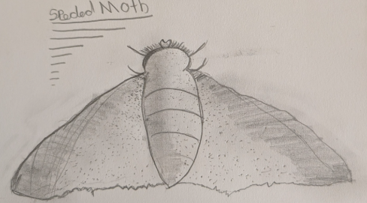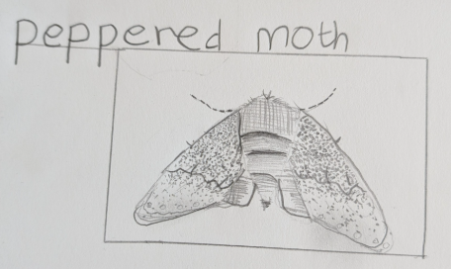
Last Term
Last term the children thoroughly enjoyed their project – Could humans ever become extinct? Here are a few examples of some of the work we completed as part of this project:

Reminders

- P.E. kit needs to be worn from home on the day your child has P.E a gentle reminder the PE uniform is : Plain black , blue or grey jogging bottoms or shorts and plain white or black t-shirt. A change of shoes is also necessary.
- Remember to refer to this term’s Knowledge Organiser for more detailed information on our current project “Do the Ancient Greeks still live on?”’. This contains lots of key words, diagrams and ideas of learning activities you can do at home.
- Please can all children bring a water bottle to school filled with water. These should be taken home at the end of the day to be washed and ready for the next day.
- Children should not be using social media platform that is not age appropriate for them and we ask all parents to check their child’s devices regularly to ensure we are keeping them safe.
- No mobile phones are allowed in school. However, if this is necessary a teacher needs to be informed and the phone handed to the office.
We look forward to a great year ahead of us filled with lots of learning and fun.

[Grab your reader’s attention with a great quote from the document or use this space to emphasize a key point. To place this text box anywhere on the page, just drag it.]
[Grab your reader’s attention with a great quote from the document or use this space to emphasize a key point. To place this text box anywhere on the page, just drag it.]
[Grab your reader’s attention with a great quote from the document or use this space to emphasize a key point. To place this text box anywhere on the page, just drag it.]
[Grab your reader’s attention with a great quote from the document or use this space to emphasize a key point. To place this text box anywhere on the page, just drag it.]
[Grab your reader’s attention with a great quote from the document or use this space to emphasize a key point. To place this text box anywhere on the page, just drag it.]
[Grab your reader’s attention with a great quote from the document or use this space to emphasize a key point. To place this text box anywhere on the page, just drag it.]

