` 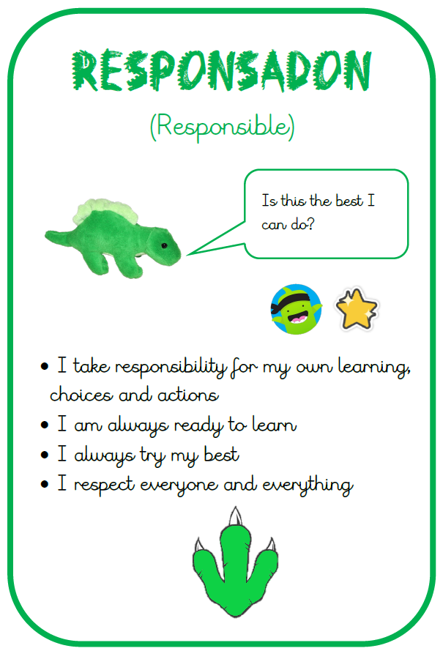
gr
- School open at 8:40am and the school day finishes at 3:15pm. Please fill out an ‘end of day arrangements form’ with the office if there have been any changes.

- P.E. kit needs to be worn from home on the day your child has P.E a gentle reminder the PE uniform is : Plain black , blue or grey jogging bottoms or shorts and plain white or black t-shirt. A change of shoes is also necessary.

- During the Spring Term, PE for all of Year 5 and 6 will be on Wednesdays.

‘Could humans ever become extinct?’ Much of our learning will be science-focused, beginning with inheritance, fossils and evolution, including the work of Charles Darwin. Pupils will explore how species change over time and what evidence helps scientists understand this. In art, children will develop their sketching skills by studying the peppered moth, linking creativity with evolution learning. After half term, science lessons will focus on the human body, the heart, the circulatory system and ways to stay healthy. We will conclude the term with art, learning about Banksy and creating printed artwork.

[Grab your reader’s attention with a great quote from the document or use this space to emphasize a key point. To place this text box anywhere on the page, just drag it.]
Spring Term 2026
This term, Year 5 pupils will take part in a ‘What Is University?’ workshop delivered by Into University. This is a fantastic opportunity to raise aspirations and help children understand future learning pathways. Year 5 pupils will also have the chance to take part in or observe a mock trial alongside children from Buswells Primary School. Barley Croft participated in this event last year and it was a great success for everyone involved, so we are really looking forward to taking part again this term and hope children take a lot from the experience.

- 13th Jan – Year 5 Into University ‘What is University?’ workshop – during the school day
- 27th Jan – Year 5 Mock Trial at Buswells Primary School
- 12th Feb – Safer Internet Parent Workshop 9 -9:30am
- Week commencing 9th Feb – Safter Internet Week
- Week commencing 9th March – National Science Week.
- 24th and 25th March – Parent’s Evening
- 30th March – 2nd April – Year 6 Easter School

School gates open at 8:35 am and your child should be in class by 8.45

P.E. kit needs to be worn from home on the day your child has P.E a gentle reminder the PE uniform is : Plain black , blue or grey jogging bottoms or shorts and plain white or black t-shirt. A change of shoes is also necessary. No logos or football kits should be worn.

Year 6: SATs Revision
Year 6 pupils have been sent home with four revision guides, along with a timetable outlining which aspects of revision should be completed each week. The answers to the activities can be found within the revision guides themselves, and families are responsible for marking this work on a weekly basis. Children are expected to bring their revision guides into school each week so they can be checked and discussed with their class teacher. This regular routine will help pupils stay on track with their revision and ensure they are well prepared as they work towards their end of Key Stage 2 assessments.
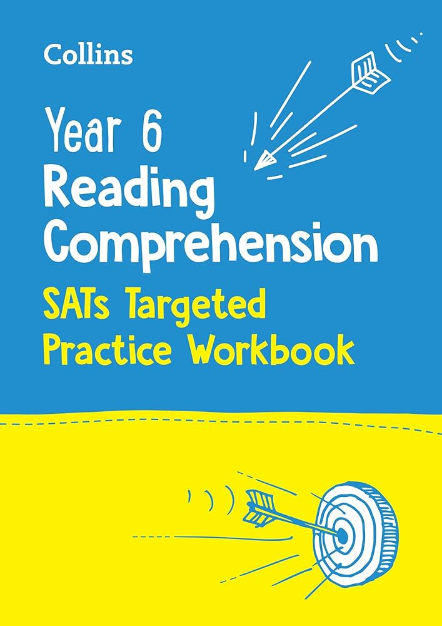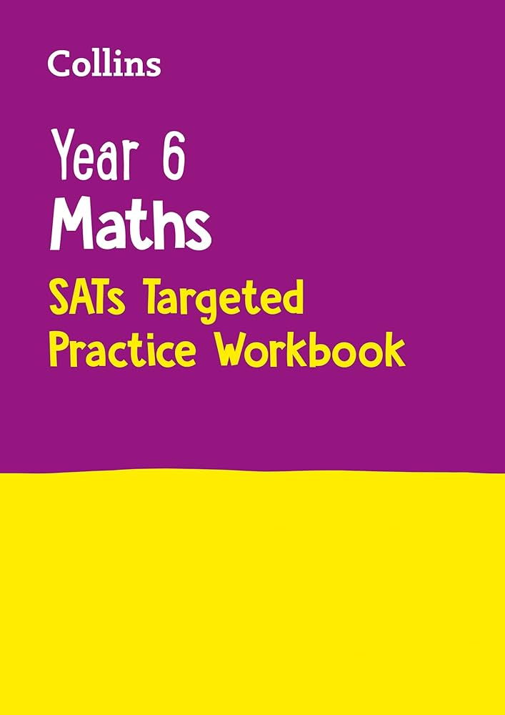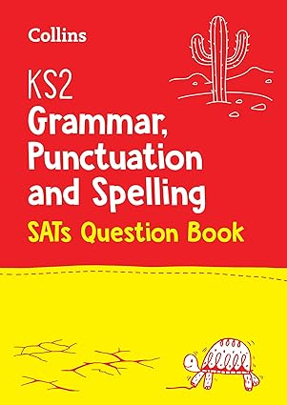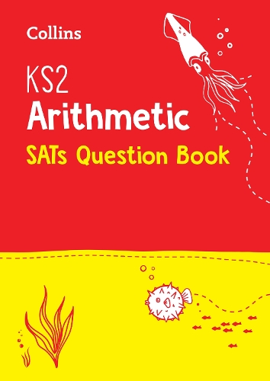
Easter School : Some children in Year 6 will be invited to attend Easter School during the first week of the Easter holidays (30thMarch – 2nd April). If your child receives an invitation, we strongly encourage them to attend, as this is a fantastic opportunity to build confidence and reinforce key skills in preparation for the Year 6 SATs. Sessions will be supportive and focused, allowing pupils to revisit important learning in a small-group setting with guidance from familiar staff. Further details, including dates and times, will be shared with invited families. We hope parents will support this valuable opportunity to help children feel confident and ready for the assessments ahead.
After School Booster Sessions: Some children will be invited to attend SATs booster sessions after school. These sessions will be carefully planned to support specific pupils in particular areas of learning, ahead of the SATs. If your child is invited, we strongly encourage them to attend every week, as regular attendance is essential for the sessions to have a meaningful impact.
If you have any questions or need any support at all with any SATs revision please speak with your child’s teacher.

Reminders
- Remember to refer to this term’s Knowledge Organiser for more detailed information on our current project ‘What can we learn from History?’. This contains lots of key words, diagrams and ideas of learning activities you can do at home.
- Please can all children bring a water bottle to school filled with water. These should be taken home at the end of the day to be washed and ready for the next day.
- Children should not be using social media platform that is not age appropriate for them and we ask all parents to check their child’s devices regularly to ensure we are keeping them safe.
- No mobile phones are allowed in school. However, if this is necessary a teacher needs to be informed and the phone handed to the office.

We look forward to a great year ahead of us filled with lots of learning and fun.

[Grab your reader’s attention with a great quote from the document or use this space to emphasize a key point. To place this text box anywhere on the page, just drag it.]
[Grab your reader’s attention with a great quote from the document or use this space to emphasize a key point. To place this text box anywhere on the page, just drag it.]
[Grab your reader’s attention with a great quote from the document or use this space to emphasize a key point. To place this text box anywhere on the page, just drag it.]
[Grab your reader’s attention with a great quote from the document or use this space to emphasize a key point. To place this text box anywhere on the page, just drag it.]
[Grab your reader’s attention with a great quote from the document or use this space to emphasize a key point. To place this text box anywhere on the page, just drag it.]
[Grab your reader’s attention with a great quote from the document or use this space to emphasize a key point. To place this text box anywhere on the page, just drag it.]

