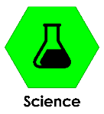
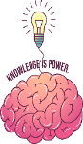
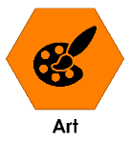
Key Knowledge – Science Evolution
During this project we will be learning these subjects:

Sticky words
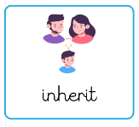
Inherit:
Receiving something from someone else
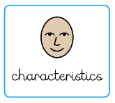
Characteristics:
Features or things about someone/something which make them recognisable
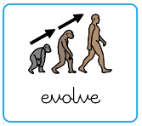
Evolve:
Change over time into something different
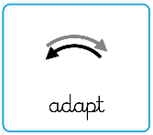
Adapt:
Change to suit the environment
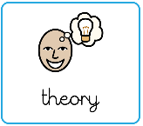
Theory:
An idea or group of ideas someone has to try and explain something
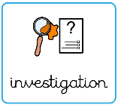
Investigation:
A careful and planned search for information and facts
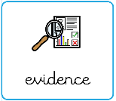
Evidence:
Facts, clues and information about something which help you to decide if something is true

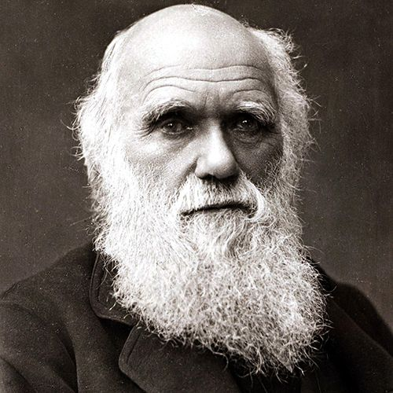
Charles Darwin was a British scientist who lived in the 1800s and is famous for developing the theory of evolution by natural selection. He travelled around the world on a ship called HMS Beagle, where he studied plants, animals, and fossils. Darwin noticed that living things had adapted to their environments in different ways. From his observations, he suggested that species change over time. His ideas helped scientists better understand how plants and animals evolve.
Charles Darwin

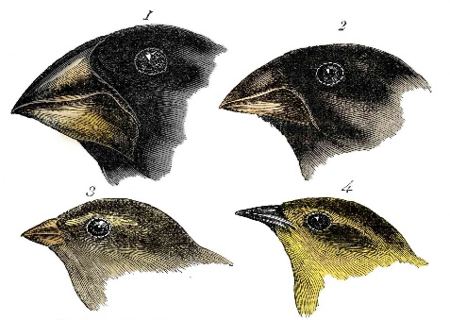
Darwin’s finches are a group of birds that live on the Galápagos Islands and helped Charles Darwin develop his ideas about evolution. The finches have different shaped beaks, which are suited to the type of food they eat, such as seeds, insects, or nectar. Finches with beaks best suited to their environment were more likely to survive and reproduce.

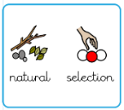
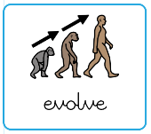
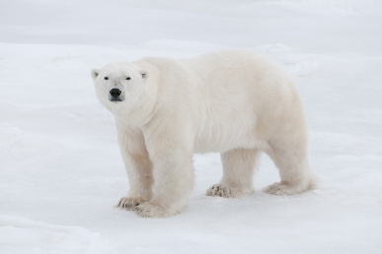
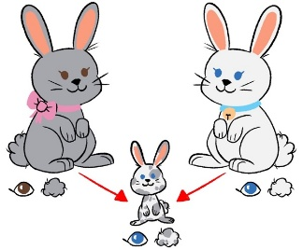
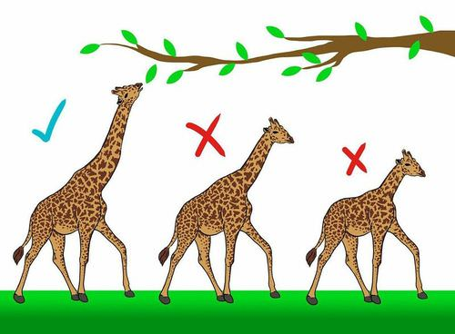
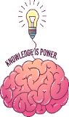
Natural Selection

All plants and animals have small differences, called variations. Some variations help them survive better, such as being faster, stronger, or better camouflaged. Living things with helpful characteristics are more likely to survive, grow, and have offspring. They pass these useful characteristics on to their young. Over many generations, this means that the species becomes better adapted to its environment.
Key Concepts

Adaptation
Adaptation is when a living thing (plant or animal) has changed to help them survive in their environment like a polar bears thick fur for warmth, a cactus’ spines for protection or a duck’s webbed feet for swimming.
Evolution

Evolution is the process by which living things change over long periods of time. These changes happen over many generations and help plants and animals survive better in their environments. Over time, small changes can add up and result in big differences in a species.
Inheritance
Have you ever told that you look like your parents? This is because we inherit features and characteristics from them e.g. our natural hair and eye colour, our height or the shape of our face. Offspring are usually similar to their parents but not exactly the same.

Key Knowledge – Science Evolution

