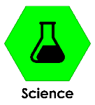
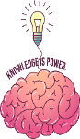
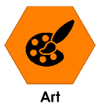
Key Knowledge – Science The Human Body
During this project we will be learning these subjects:

Sticky words
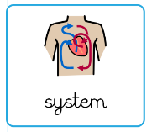
System: a set of connected parts that work together as a whole.
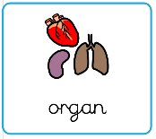
Organ: a part of the body made of different tissues that works to perform a specific function.
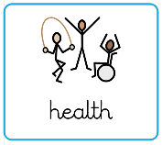
Health: how well your body and mind are working and how you feel overall.
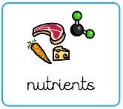
Nutrients: substances in food that help the body grow and stay healthy.
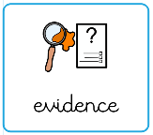
Evidence: useful substances in food that the body needs to stay healthy.
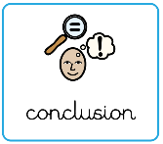
Conclusion: a statement that explains what you have learned from an experiment or investigation.

Science Investigations
A scientific investigation is a method used to explore questions and test ideas about the world around us. It involves making a prediction, called a hypothesis, and then carrying out an experiment or study to gather evidence. Scientists collect and record data carefully, look for patterns, and use the results to draw conclusions. Investigations are controlled so that only one variable changes at a time, making the results fair and reliable.

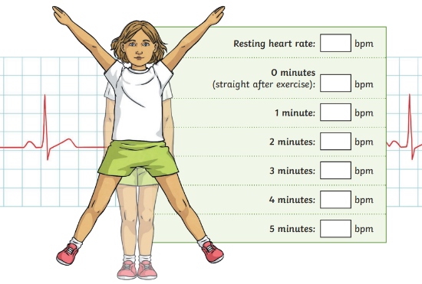

Our Investigation
This term, children will take part in a scientific investigation to explore the effects of exercise on heart rate. Children will be expected to make a prediction, record evidence, interpret results and write up using scientific language, including a clear method, results, and conclusion.

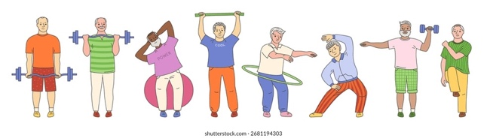
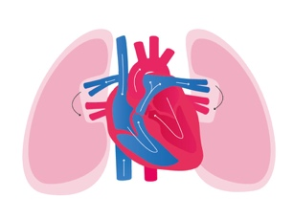
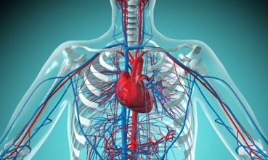
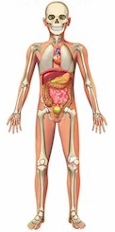
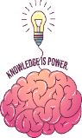
Diet and Nutrition
A healthy diet is important for the body to grow, repair itself, and stay strong. Eating a variety of foods gives the body the nutrients it needs. Drinking enough water is also essential. Eating too much sugar, salt or unhealthy fats can lead to health problems, while a balanced diet combined with regular exercise helps the body work well, supports the immune system, and keeps the heart, bones, and muscles healthy.
Exercise
Exercise has a big impact on the human body. It strengthens the heart and muscles, improves lung capacity, and helps blood circulate more efficiently. Regular activity also boosts energy, supports healthy bones and joints, and helps maintain a healthy weight. Exercise can improve mood and reduce stress by releasing chemicals called endorphins. It also helps the body stay fit and better able to fight illness.
The Circulatory System
The circulatory system is the network of blood vessels and organs that work together to move blood around the body. It is sometimes referred to as the cardiovascular system. The word ‘circulatory’ means something that is going round and round in a circle or loop. This is exactly what is happening in our bodies all the time
The Heart and lungs
The heart and lungs are key organs in the body. The heart is a muscular pump that moves blood around the body, delivering oxygen and nutrients to cells and carrying away waste like carbon dioxide. The lungs are responsible for breathing in oxygen from the air and removing carbon dioxide from the blood. Together, the heart and lungs work closely: blood flows from the heart to the lungs to collect oxygen, then back to the heart to be pumped around the body
Key Knowledge – Science
The Human Body

