` 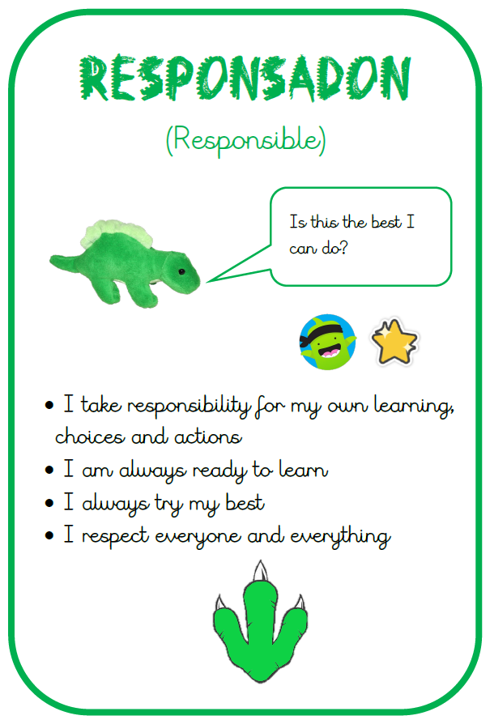
gr
- School open at 8:45am and the school day finishes at 3:15pm. Please fill out an ‘end of day arrangements form’ with the office if there have been any changes.

- P.E. kit needs to be worn from home on the day your child has P.E a gentle reminder the PE uniform is : Plain black , blue or grey jogging bottoms or shorts and plain white or black t-shirt. A change of shoes is also necessary.

- PE days for each class this term are:
- Liberty – Tuesday
- Community – Wednesday
- Tolerance - Thursday

What can we learn from History?
We will begin our Project with Geography – locating the world’s countries, focusing on Europe and Countries involved in WW2. After this, we will move into our History learning all about WW2. The children will learn: when WW2 occurred, why it started, what countries were involved, the role of key individuals, what it was likes during the Blitz and what the Holocaust is. After half term, we will begin to learn about Space and will look at the connection between the end of WW2 and the Space Race.

Autumn Term 2025
Homework expectations
- Children have been sent home with a new yellow reading diary. This should be at school every day with their levelled reading book. Children are expected to read x4 per week. Reading diaries need signing by an adult.
- Children have been sent home with access codes for SeeSaw. If you have any problems with this, please speak with your child’s teacher.
- Children also have access log-ins to Times Tables Rock Stars and Bug Club where they can practice their tables and read a levelled book online.
- Weekly homework – Weekly Maths and English homework will be set every Friday. This will be available on See Saw and paper copies will be available.
- We will also be setting a family homework challenge related to our real project - more information about this is coming soon.

School gates open at 8:35 am and your child should be in class by 8.45

P.E. kit needs to be worn from home on the day your child has P.E a gentle reminder the PE uniform is : Plain black , blue or grey jogging bottoms or shorts and plain white or black t-shirt. A change of shoes is also necessary. No logos or football kits should be worn.

- 5th Sept – Project Knowledge Organisers sent home. More detail about what the term’s Project will entail.
- 9th Oct – KS2 Book Look – A chance to come into classrooms and see some of the learning that has been taking place.
- 17th Oct – Inset day – School closed to children.
- 20th – 24th Oct – Half Term
- 31st Oct – Harvest Festival
- 3rd – 7th Nov – Year 6 Into University Focus Week. Focus – Zoology
- 18th and 19th Nov – Parent’s Evening
- 11th Dec – Winter Disco
- 18th Dec – Last day of term

[Grab your reader’s attention with a great quote from the document or use this space to emphasize a key point. To place this text box anywhere on the page, just drag it.]
[Grab your reader’s attention with a great quote from the document or use this space to emphasize a key point. To place this text box anywhere on the page, just drag it.]
[Grab your reader’s attention with a great quote from the document or use this space to emphasize a key point. To place this text box anywhere on the page, just drag it.]
Great start to the year!
We have had a brilliant start to the year settling back in and getting to know each other. Throughout the first 4 days back, we focused on our learning powers: responsible, reflective, resourceful, reciprocal and resilient. This has been a real positive start and we will continue to work upon and develop these key learning behaviors throughout the year.

We also enjoyed a really lovely trip to Bradgate Park. This day was filled with lots of walking, team building games and opportunities for us to get to know each other.

Reminders
- Remember to refer to this term’s Knowledge Organiser for more detailed information on our current project ‘What can we learn from History?’. This contains lots of key words, diagrams and ideas of learning activities you can do at home.
- Please can all children bring a water bottle to school filled with water. These should be taken home at the end of the day to be washed and ready for the next day.
- Children should not be using social media platform that is not age appropriate for them and we ask all parents to check their child’s devices regularly to ensure we are keeping them safe.
- No mobile phones are allowed in school. However, if this is necessary a teacher needs to be informed and the phone handed to the office.

We look forward to a great year ahead of us filled with lots of learning and fun.

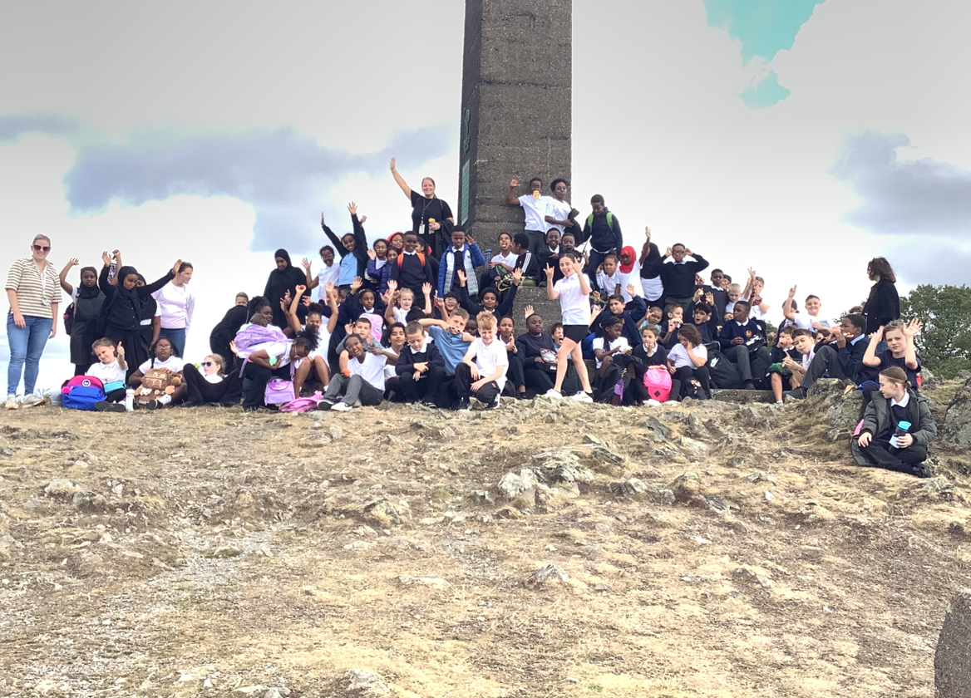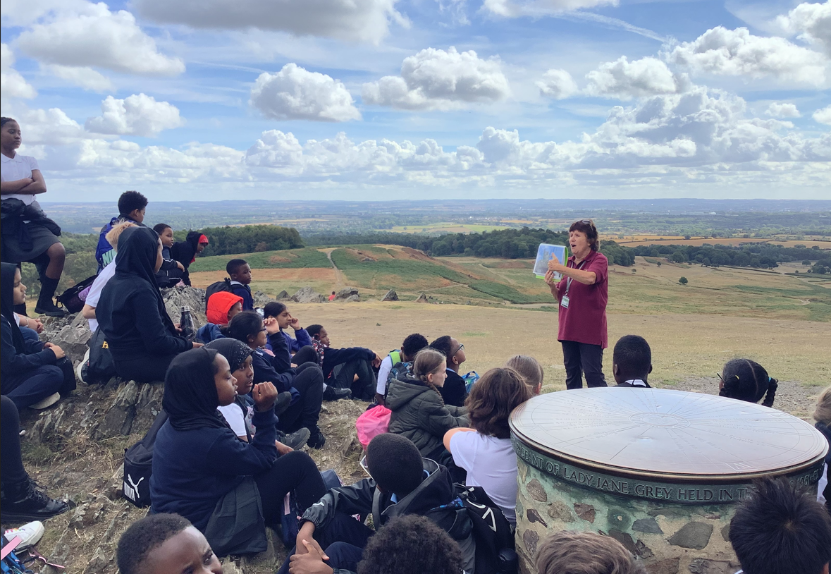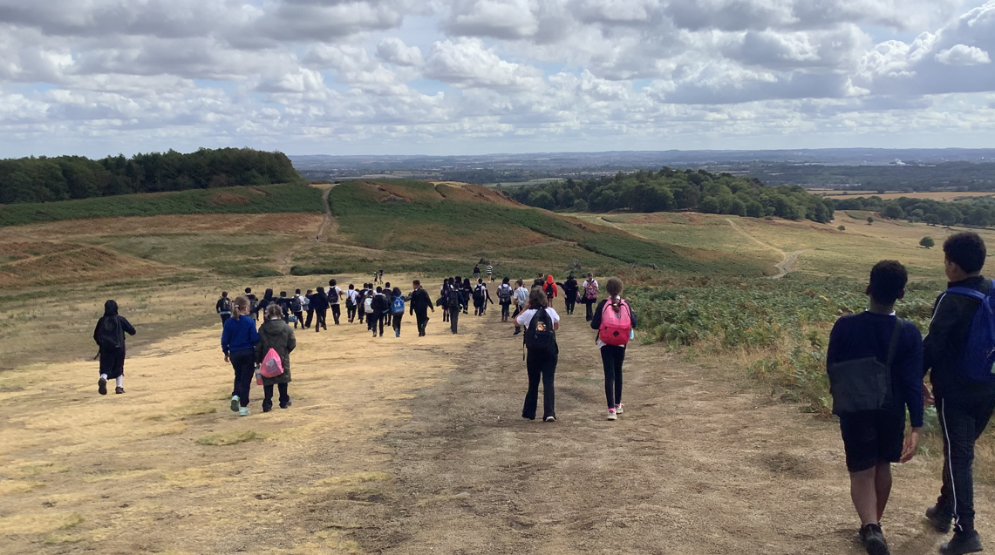
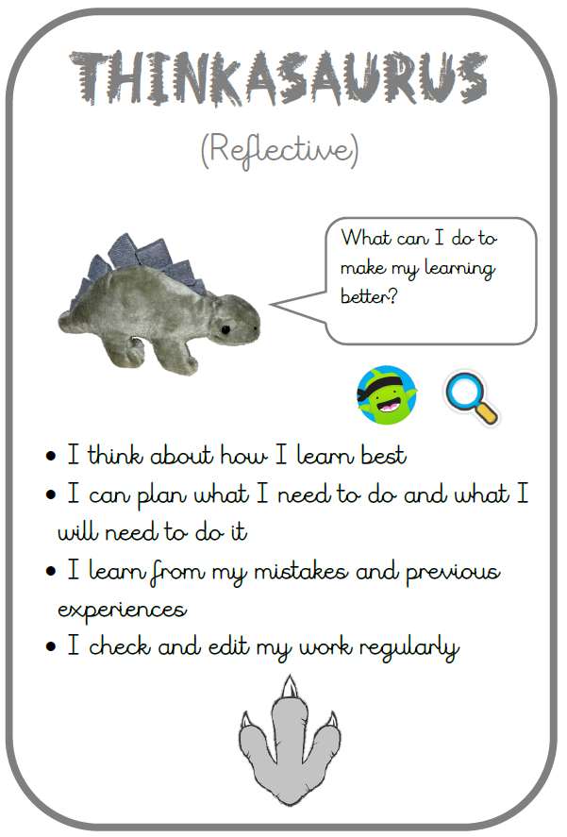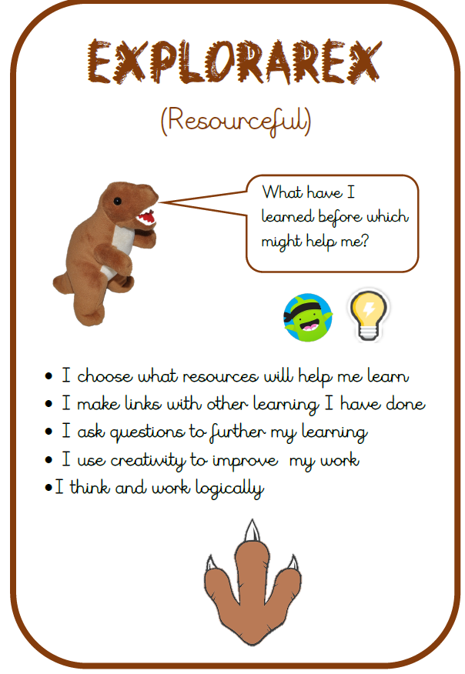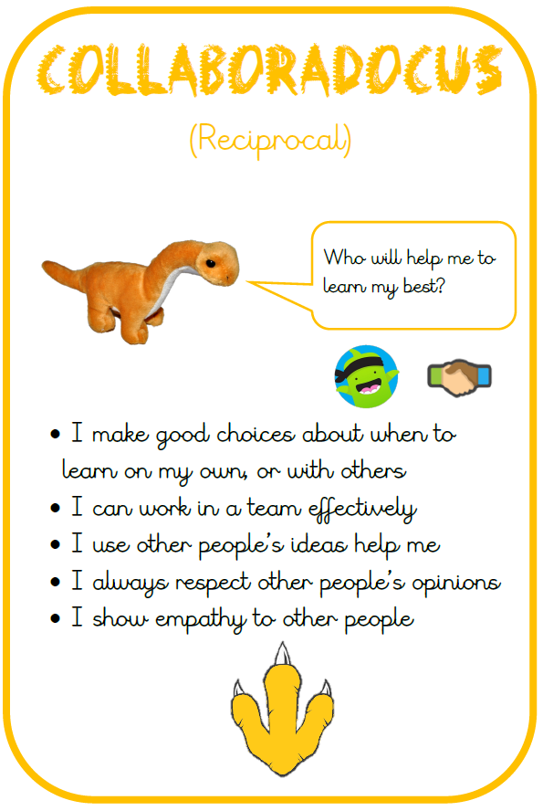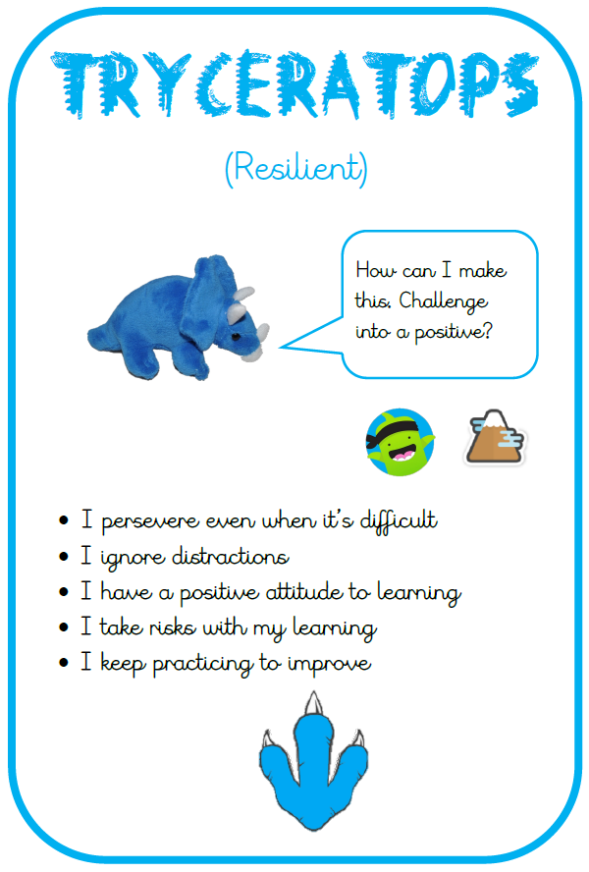
[Grab your reader’s attention with a great quote from the document or use this space to emphasize a key point. To place this text box anywhere on the page, just drag it.]
[Grab your reader’s attention with a great quote from the document or use this space to emphasize a key point. To place this text box anywhere on the page, just drag it.]
[Grab your reader’s attention with a great quote from the document or use this space to emphasize a key point. To place this text box anywhere on the page, just drag it.]

