

The staff that make up team Respect are as follows –
Lucy Smith – Class teacher (Monday to Thursday)
Vicky Stoddart – Specialist Teaching Assistant (all week)
Stephan Mills – Specialist Teaching Assistant (Tuesday to Friday)
Sally Clayton – Teaching Assistant (all week)

If you have any concerns, please feel free to talk to us at the end of the day or by phone. You can also send the team a message on Seesaw.

September 23rd – School Photo’s

Schools finishes for half term at 3:15pm on
Thursday 16th October.

Parents evening – November 18th and 19th

School finishes for Christmas at 3:!5pm on Thursday 18th December. Returning Tuesday 6th January.
Want to boost learning at home? Here are some easy ideas:
- Chat lots! The more your child talks, the more confident they’ll feel. Try questions that start with what, where or why to get them thinking and sharing.
- Board games are brilliant. Counting spaces and taking turns builds early maths skills and helps with patience and teamwork.
Simple, everyday fun makes a big difference!

This term in English, the children are reading Emmanuel’s Dream. Through this story, they’ll explore resilience, what makes them unique and individual, and what it means to be a “Tryceratops” – never giving up. To finish the project, they will write their own descriptive piece celebrating these skills.
Our REAL project this term is All About Me. The children will be learning about where we live, exploring our home city, and discovering how the human body works – including what it needs to stay healthy and strong.

Autumn Term 2025
Information from the timetable this half term
📚 Reading – Books go out and change every Thursday. Please read daily, sign the diary, and aim for 4 signatures a week – that’s 5 Dojo points!
✏️ Homework – Set on Wednesdays, due back the following Wednesday. Log-ins for TTRS, Numbots and Bug Club are in homework books. Dojo points awarded!
🌳 Outdoor Learning – Every Tuesday afternoon. Please send a coat (and wellies if possible). Donations of spare waterproofs welcome.
👩‍🍳 Cooking – Every Thursday afternoon.
🎶 Choir – Every Wednesday afternoon.
👕 Uniform & PE – Correct uniform should be worn every day. On your child’s PE day, children must remove all jewellery. If you’re unsure which day your child has PE please ask.
So far this term
We have spent lots of time settling back into school and establishing our classroom and school routines. Our work this week has focused on learning about the schools’ learning powers. These are skills that we will use every day in school and throughout life to build our resourcefulness, our resilience, our reflective skills, understand our responsibilities and be reciprocal.
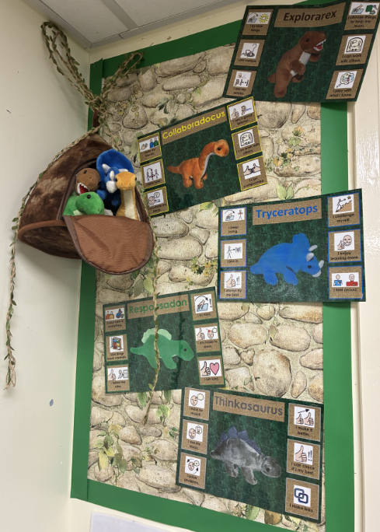
If you have any questions, please catch us at drop-off/pick-up or message via Seesaw.
Thanks for your support, Respect Class Team 😊

