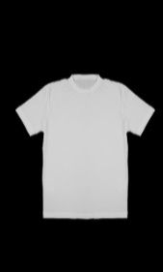
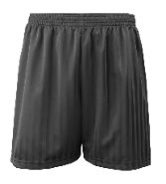
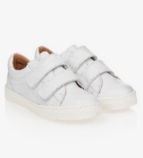
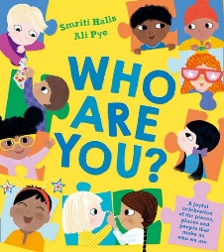
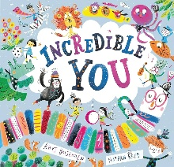
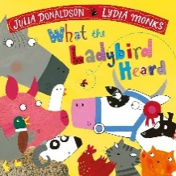
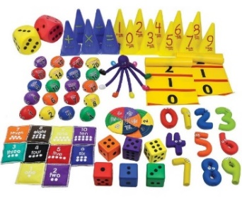
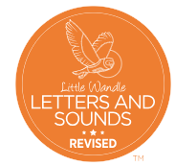
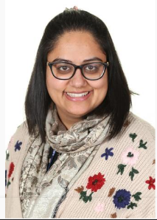
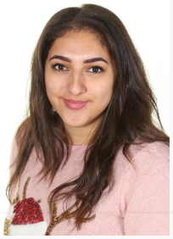
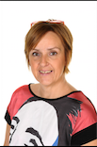

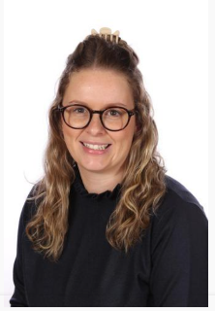
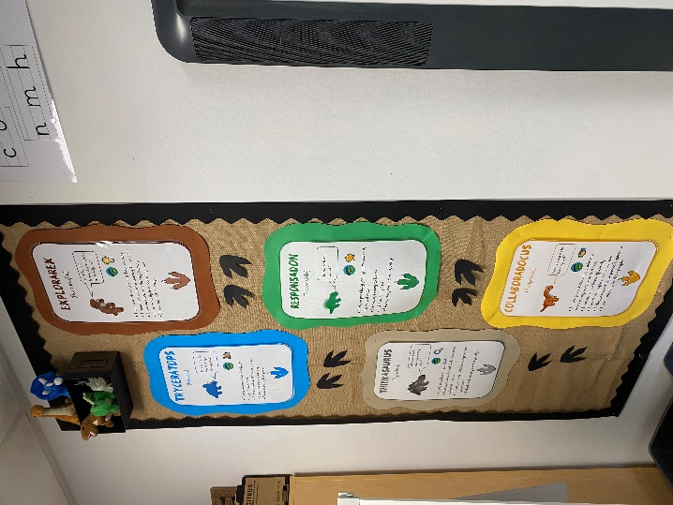
After Half Term:
History – The Gunpowder Plot

I wonder what makes me marvellous?
Subjects we will be learning are:
- Art – Self Portraits
- Geography – Where am I from?
- History – Changes within living memory
- Science – Human body, Living things & Staying healthy
I wonder what makes me marvellous?
Subjects we will be learning are:
- Art – Self Portraits
- Geography – Where am I from?
- History – Changes within living memory
- Science – Human body, Living things & Staying healthy
Please see the Knowledge Organiser for key learning and vocabulary linked to our Project.
Reading
We expect children to read at home daily.
Please look after school books and return them every week so your child’s book can be changed.
Kindness (Year 1/2) book change: Thursday
Courage (Y1) & Honesty (Year 2) book change: Friday
Maths
Please encourage your child to practise number formation, number facts and times tables (Y2) every day.
Homework
Weekly Maths and English homework is set for pupils to complete at home on our online learning platform, Seesaw, every Friday. This will begin on 12.9.25. If you require paper homework, please speak to your child’s class teacher.
Please encourage your children to remember the ‘Learning Powers’ at school and home. Look out for certificates coming home for super learning!

PE
We expect to come to school wearing their Barley Croft PE kit on the days when their class has PE; they will not get changed at school. We expect children to be wearing the Barley Croft PE kit:
• Plain black/navy shorts or plain black/navy jogging bottoms • Plain white T-shirt (a white PE T-shirt with the Barley Croft logo can be purchased from the school office) • White, black or blue trainers (not high-tops/boots).
> Honesty class (Mr Easton - Y2) – Friday
> Kindness class (Mrs Winfield – Y1/2) – Friday
> Courage class (Miss Banning – Y1) – Tuesday
Tuesday 16th September
EYFS & KS1 Parent meeting with Reading & Phonics Lead – 2.30pm in the school hall
Tuesday 23rd September
School Photos
Monday 6th October
After school clubs begin
Thursday 16th October
Break up for Half Term @ 3.15pm
Monday 27th October
Return to school after Half Term
Tuesday and Wednesday 18th and 19th November
Parents Evening

Autumn Term 2025
Please encourage your children to remember the ‘Learning Powers’ at school and home. Look out for certificates coming home for super learning!
For our first Writing unit this year, we are writing an autobiography, based on the book: Who Are You? We look forward to learning all about the pupils and your families as we write in the next few weeks.
After that, we will be using the lovely book, ‘Incredible You’ and giving children the opportunity to plan and write their own endings to the story.
Later in the term, we will be writing a narrative, inspired by the excellent text, What The Ladybird Heard, by the famous author, Julia Donaldson.
In our Maths lessons this term,
we will be learning…
Year 1:
Numbers to 10
Part Whole models within 10
Addition and subtraction within 10
2D and 3D shapes
Year 2:
Numbers to 100
Addition & Subtraction
Properties of Shape
Phonics – Learning to Read
We use the Little Wandle scheme for Phonics – teaching pupils to read. Children will be grouped based on individual assessments to ensure they are learning at an appropriate stage. Reading books we send home are carefully matched to children’s Phonics ability.
Parent resources to support Phonics at home can be found here:
https://www.littlewandlelettersandsounds.org.uk/resources/for-parents/

Meet the staff in the Year 1/2 team this term:
Mrs Winfield Miss Banning Mr Easton Mrs Miller Miss Bliss
Some of the additional, amazing adults in our phase this year are:
Miss Billie, Mrs Huntley, Miss Andrews and Miss Khan.

