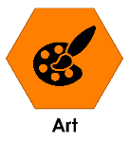
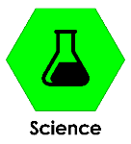
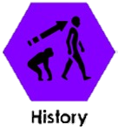

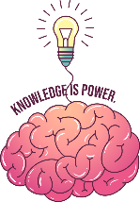
Key knowledge – History
During this project we will be learning these subjects
Sticky words
 | The order in which events happen.
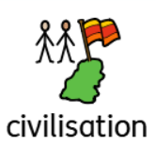 | A large group of people who live together in an organised way . For example, sharing the same language following the same law.
 | To enter a place with an army to take control.
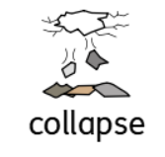 | The breakdown of civilisation.
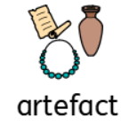 | Object that provides us clues about the past.
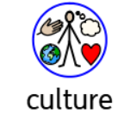 | The unique way a group of people live , including how they dress , the religion they follow the beliefs they have.

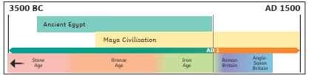
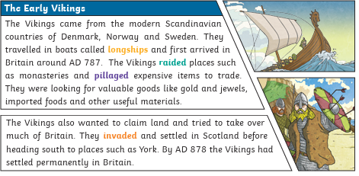
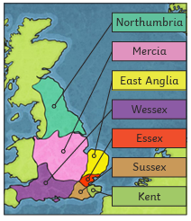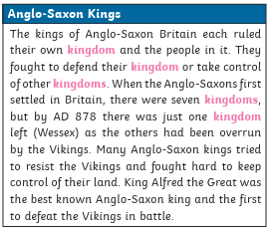

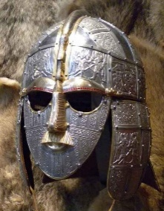
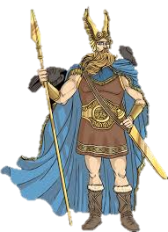
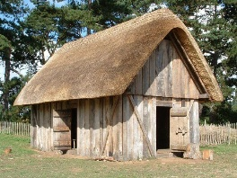
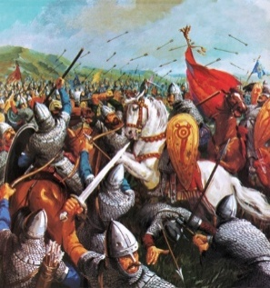
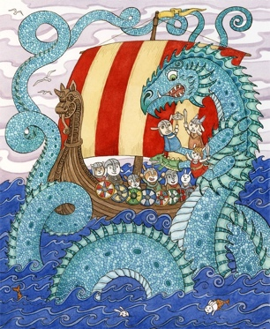
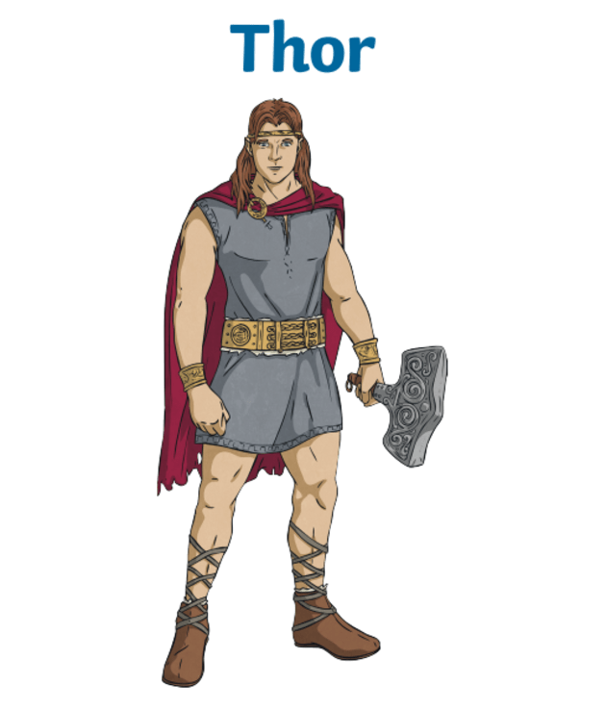
ANGLO-SAXONS | VIKINGS
RELIGION:  - The religion of the early Anglo-Saxons was Paganism. They worshipped many gods.  - Festivals and sacrifices were made to the gods and goddesses. Pagans also believed in good and bad omens, lucky charms, spells and magic.  - In AD 597, a Roman monk called Augustine was sent to tell the Anglo-Saxons about Christianity. King Ethelbert of Kent was the first to be converted and was baptised along with 10,000 of his people. Over the next 100 years, the rest of the kingdoms converted to Christianity too. | RELIGION:  - Viking religion was based on Norse mythology in many gods, goddesses, and other beings like giants and elves, with.  - The Vikings believed in a cosmos of nine different realms, including Asgard (home of the gods) and Midgard (the human world). After death, brave warriors could join Odin in Valhalla, while most others went to Helheim, a cold, dark realm.  - The Vikings also believed in Ragnarök, a final battle that would signal the end of the world.
HOW THEY LIVED:  - The Anglo-Saxons created many settlements. These were small villages, often built by clearing trees from land near a water source like a river.  - Anglo-Saxon villages usually had a large hall where the chief lived. Villagers could also meet together there. Families would live in smaller houses around the hall.  - Buildings mostly had thatched straw roofs and walls made of wooden planks or wattle and daub.  - Villages were usually surrounded by ploughed fields that were used for growing crops.  - Livestock, like cows and sheep, would live among the people. | HOW THEY LIVED:  - Vikings lived on farms and kept cows, pigs and sheep for milk, wool and meat.  - Houses - Walls made of stone or wood. A straw roof. Wattle and daub (sticks and mud/dung) for the inside of the walls.  - Jewellery - Worn to show off how rich a person was.  - Sagas - Vikings used rhyme to tell stories about adventures and battles against monsters.
STRUGGLE FOR BRITAIN: William, the Duke of Normandy, thought he should be king so came to fight Harold in the Battle of Hastings (AD 1066). Harold was shot through the eye with an arrow and died in the battle. William of Normandy, who became known as William the Conqueror, became King, bringing the Viking and Anglo-Saxon age to an end in AD 1066.
Physical features:  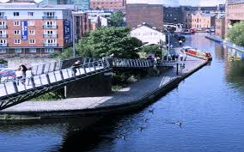 | Physical features:  

