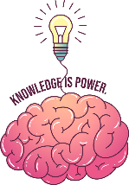
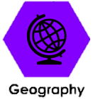
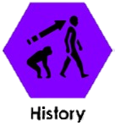


Key knowledge – Science
During this project we will be learning these subjects
Sticky words
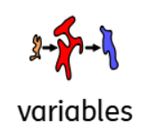 | A variable is anything that can be changed, measured, or controlled in an experiment
 | To show something is true or prove it right.
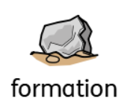 | The process of how something is made.
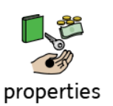 | Properties are words that describe what a material is like. For example, hard, soft or strong. They help us to decide which is the best material for a certain object. Transparent. Transparent means that you can see through a material.

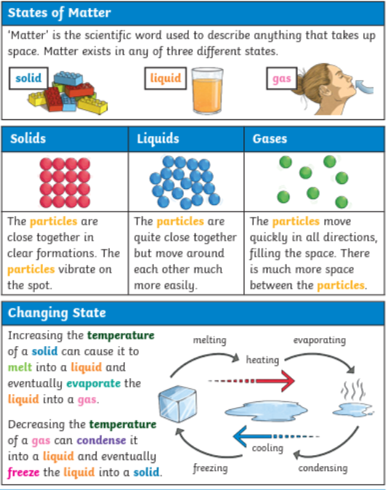

Types of rock
Key knowledge –Science 

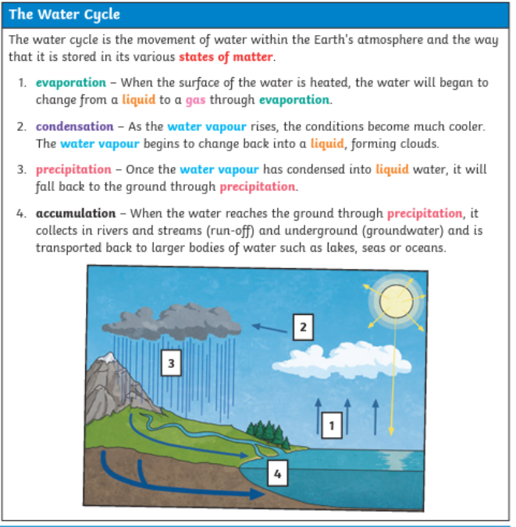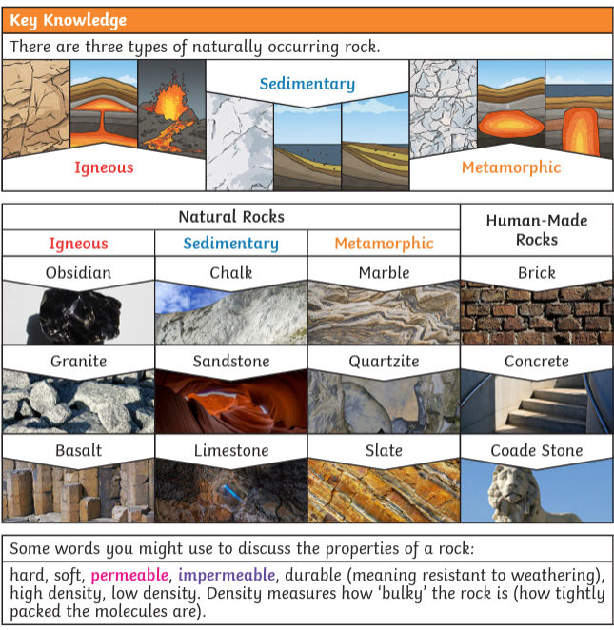
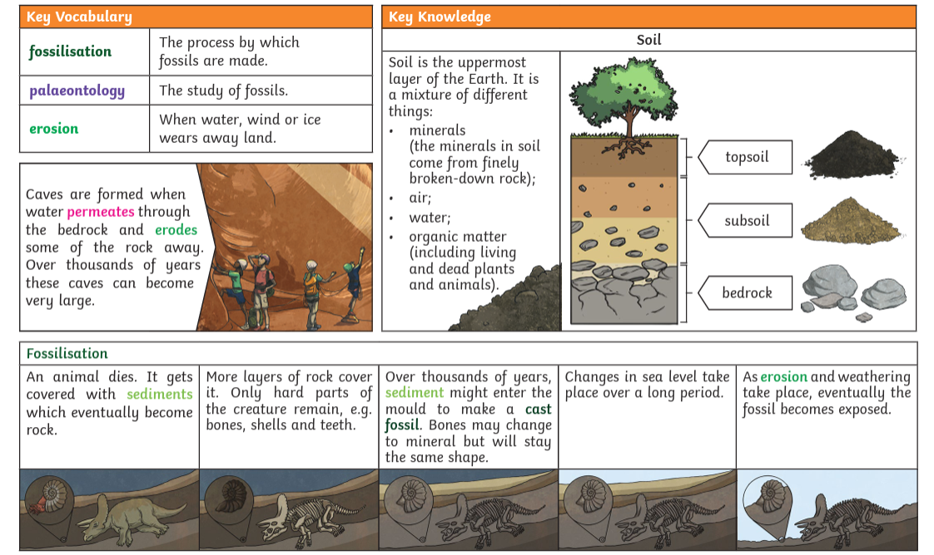

Key knowledge –Geography

Europe
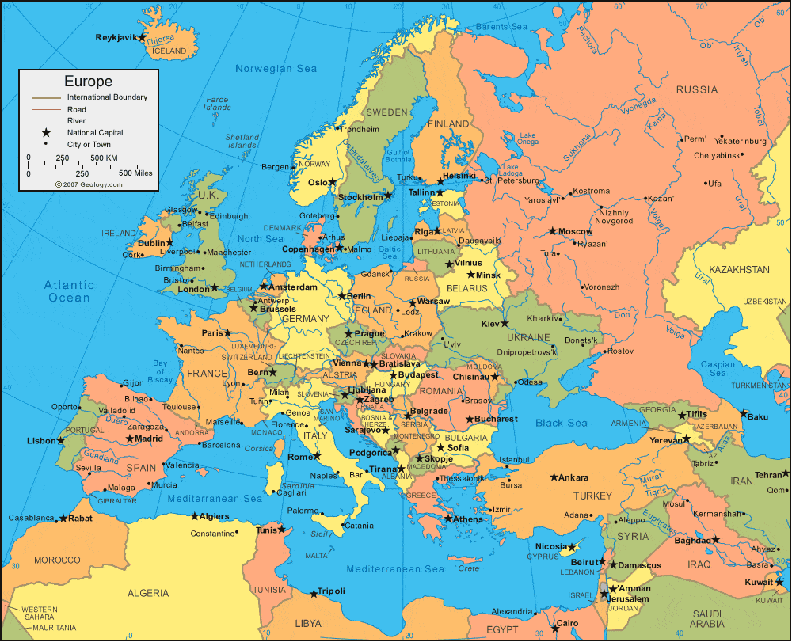
Can you find Copenhagen?
Can you find Birmingham?
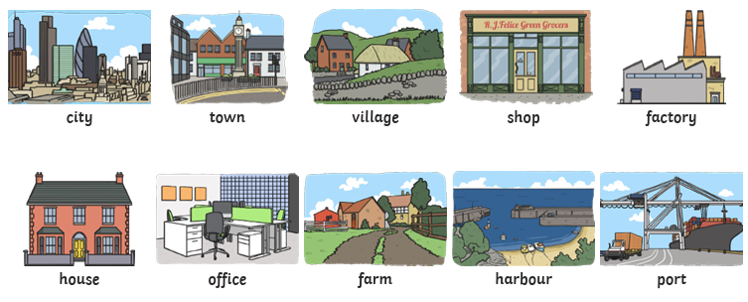
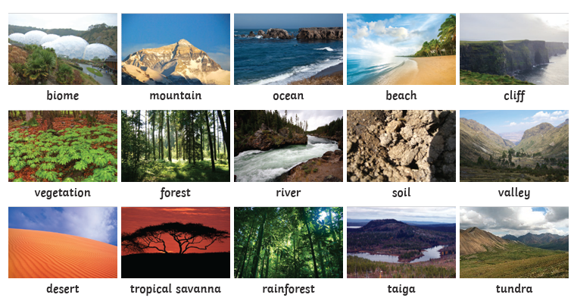
Key knowledge –Geography

HUMAN FEATURES
PHYSICAL FEATURES
BIRMINGHAM | COPENHAGEN
In Europe | In Europe
It is the second-largest city in Britain, often called the second city of the United Kingdom. | Copenhagen is the capital and largest city in Denmark
Population: About 1.158 million people live in the city itself | Population: About 1.4 million people
Language spoken: Mainly English | Language spoken: Danish
WORLD FAMOUS LANDMARK:  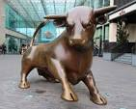  Bullring | WORLD FAMOUS LANDMARK:  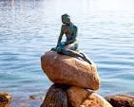  Little Mermaid statue
Physical features:  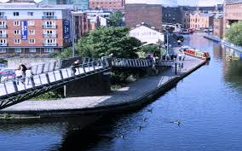 | Physical features:  

