
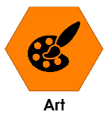

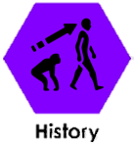
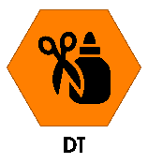
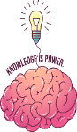
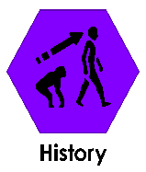
During this project we will be learning these subjects:
Key Knowledge – History WW2

Sticky words
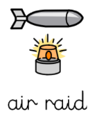 | Army planes sent to bomb an area.
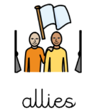 | One side of the war. Britain’s main allies during the war were America, France and the Soviet Union.
axis | The other side of the war. Mainly Germany, Japan and Italy.
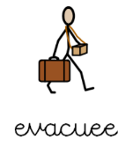 | Someone who was moved from a dangerous area (like a city) to a safer place (like the countryside).
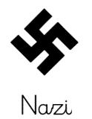 | A German soldier.
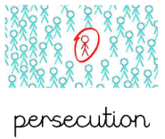 | Continually treating others in a cruel way because of race, religion or politics
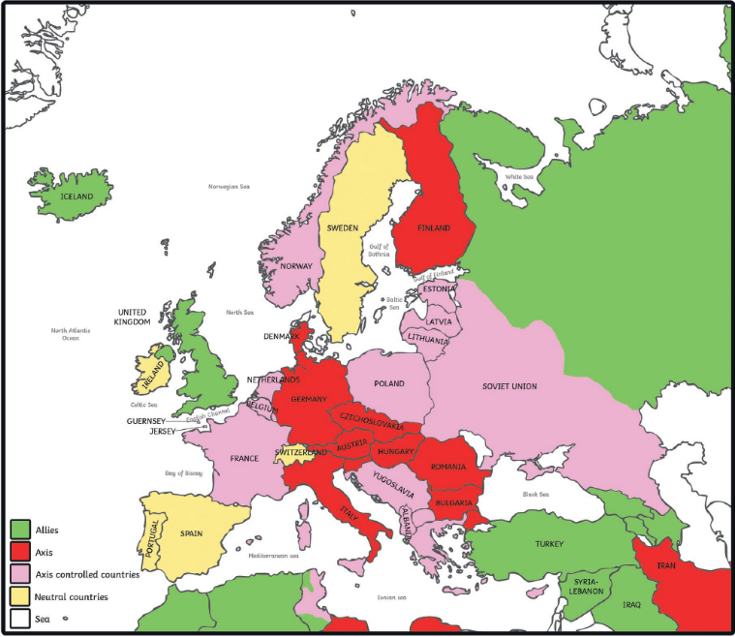
Who was involved in WW2?
How did WW2 start?
Britain and France had promised to protect Poland from the Nazis. On 1st September 1939 Germany invaded Poland. When they refused to leave, Britain and France declared war on Germany.
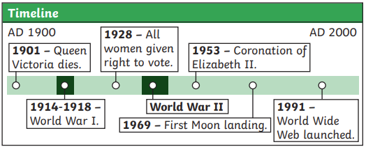

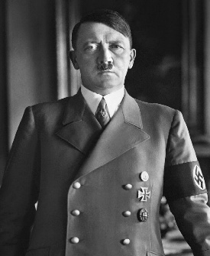
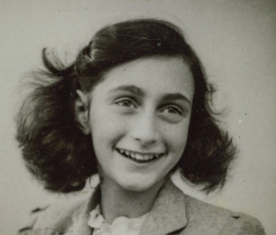
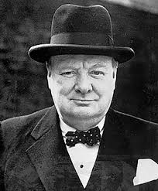
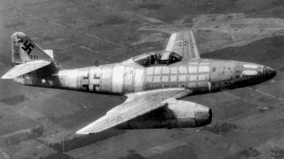
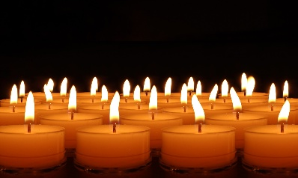
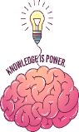
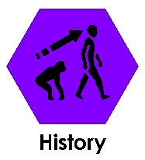
Key People

Winston Churchill Winston Churchill was the
Prime Minister during most
WW2. He was very good at
giving speeches and keeping people’s spirits up during the war.
Adolf Hitler
Adolf Hitler ruled in Germany during the war. He believed Germans were born to rule over other people and had many plans to invade and occupy many countries around the world.
Anne Frank Anne Frank was a Jewish
girl who hid from the Nazis
during the war. Anne Frank
and her family hid in a secret
annex behind a bookcase for over two years. While in hiding, Anne wrote in her diary about her fears and dreams of freedom. Her diary is now very famous around the world.
Key Events

The Blitz
For 8 months during the war, Germany began to bomb many parts of the UK. This time of intensive bombing is known as ‘The Blitz’.
The Holocaust
The Holocaust is a period of time during the war where millions of people (mainly Jewish) were persecuted and killed by the Nazis. Many believe is important to learn about The Holocaust so we can remember those who suffered.
Key knowledge – History -WW2

