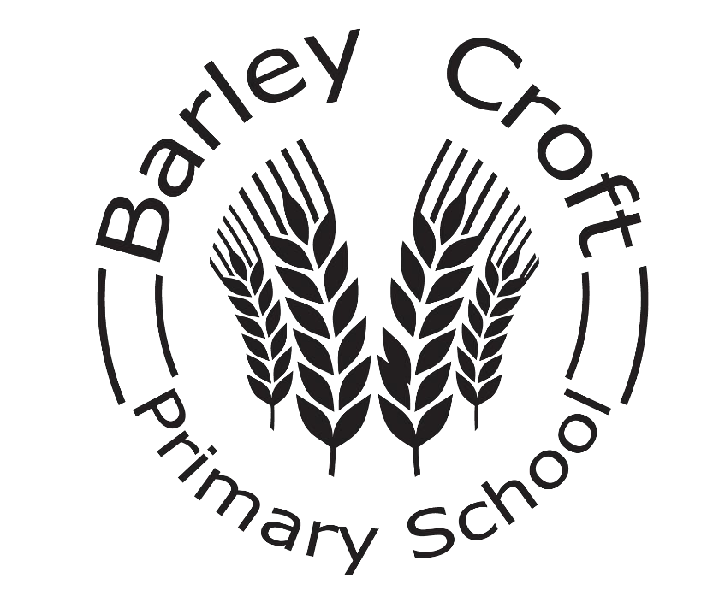

Special Educational Needs and Disability
(SEND) Policy

Signed………………………. (Chair of Governors)

Date………………………….

Signed………………………. (Headteacher)

Date………………………..

Reviewed: September 2025

Barley Croft Primary School Special Educational Needs and Disability (SEND) Policy
Barley Croft Primary School is an inclusive school. We take safeguarding very seriously and all of our policies are developed with a high priority on children’s safety and in the light of our safeguarding policy. All of our school policies are interlinked and should be read and informed by all other policies.
This SEND policy is written to comply with the 2014 Children and Families Act and its SEND Code of Practice together with the Equality Act 2010.

The SEND team at Barley Croft Primary School
Inquiries about an individual child’s progress should be addressed at first to the class teacher since he or she is the person who knows the child best. Other enquiries can be addressed to:
Becci Bonshor – SENDCo
Gretel Stonebridge – SEND link Governor
Please make an appointment with the school office if you wish to speak to the SENDCo.

Headlines from the 2014 Code of Practice
- No more statements will be issued by the Local Authority (LA). Statements have been replaced by
Education, Health and Care Plans (EHC Plans) which can be used to support children from birth – 25 years.
- School Action and School Action Plus have been replaced by one school based category of need known as ‘Special Education Needs Support’ (SENS). All children are closely monitored and their progress tracked each term. Those at SENS are additionally tracked by the SENDCo.
- There are four broad categories of SEND:
  - Communication and interaction (such as autistic spectrum and language disorders)
  - Cognition and learning (such as dyslexia, dyspraxia and dyscalculia, moderate learning difficulties and global development delay)
  - Social, emotional and mental health (such as ADHD, ADD, attachment disorders, emotional
difficulties, mental health difficulties)
  - Physical and sensory (such as hearing or vision impaired)

We have children in all these categories of SEND, and some children may have difficulties in more than one category. This may include children with a diagnosis as well as those with learning profiles consistent with the diagnosis.
- We strive to work closely with parents and children to ensure that we take into account the child’s own views and aspirations and the families’ experience of, and hopes for, their child. Families are invited to be involved at every stage of planning and reviewing SEN provision for their child.
- All children benefit from ‘Quality First Teaching’: this means that teachers assess, plan and teach all children at the level which allows them to make progress with their learning. In addition, we implement some focused interventions to target particular skills.
- We have high expectations of all our children. Tracking and monitoring of our SEND children is in line with whole school practice. Some children who are making particularly slow progress outside of their key stage expectations may be tracked using a small steps tracking assessment software.

Defining SEN
The 2014 Code of Practice says that:
A person has SEN if they have a learning difficulty or disability which calls for special educational provision to be made for him or her. At compulsory school age this means he or she has a significantly greater difficulty in learning than the majority of others of the same age, or, has a disability which prevents or hinders him or her from making use of facilities of a kind generally provided for others of the same age in mainstream schools.
Taken from 2014 SEN Code of Practice: 0 – 25 Years; Introduction xiii and xiv

SEND at Barley Croft Primary School
Our objectives are:
- To identify, at the earliest opportunity, barriers to learning for pupils with SEND
- To ensure that every child experiences success in their learning and achieves to the highest possible standard
- To enable all children to participate in lessons fully and effectively
- To value and encourage the contribution of all children to the life of the school
- To work in partnership with parents and families
- To work with the Governing Body to enable them to fulfil their statutory monitoring role with regard to this document.
- To work closely with external support agencies, where appropriate, to support the need of individual pupils.
- To ensure that all staff have access to training and advice to support quality teaching and learning for all pupils.
Around 23.3% of our children are either at SEND Support (SENS) or have statements/ EHC Plans. This is above national average of 15.9 % due to the fact that we have a Designated Specialist Provision within our school however it also means that all teachers expect to teach children with SEND within their classes.

Identifying children at SENS (SEND Support)
Children with SEN are identified by one of three assessment routes all of which are part of the overall approach to monitoring progress of all pupils:
- The progress of every child is monitored at regular pupil progress meetings. Where children are identified as not making progress in spite of Quality First Teaching they are discussed with the SENCo and a plan of action is agreed with the teacher and shared with parents via the class teacher.
- Class teachers are continually aware of children’s learning. If they observe that a child, as recommended by the 2014 Code of Practice, is making less than expected progress, given their age and individual circumstances, they will seek to identify a cause. This can be characterised by progress which:
  - Is significantly slower than that of their peers starting from the same baseline
  - Fails to match or better the child’s previous rate of progress
  - Fails to close the attainment gap between the child and their peers

- Parents sometimes ask us to look more closely at their child’s learning. We take all parental requests seriously and strive to investigate them all. Frequently, the concern can be addressed by Quality First Teaching or some parental support. Otherwise, a graduated response is implemented by school. This may result in the child being placed on the SEND register at SENS.

The SENDCo or other trained staff may need to undertake a range of standardised tests with children. These assessments can be used to add to and inform teachers’ own understanding and assessments of a child.
Although the school can identify special educational needs, and make provision to meet those needs, we do not offer diagnoses. Parents are advised to contact their GP if they think their child may have an underlying medical condition or disability.

Working with Parents and Children
We aim to have good and informative relationships with all of our parents. If a child is experiencing difficulties, parents will be informed either at parents’ meetings (autumn and spring terms) or during informal meetings to discuss the child’s progress. Children receiving interventions will have their progress tracked throughout the time they are receiving the support.
A formal written end of year report will be sent at the end of the summer term. Other informal meetings or telephone calls may be scheduled at other times throughout the year and parents are welcome to seek advice and support about their child at any pre-arranged time.

Reporting and reviewing support for children at SENS (SEN Support)
Once a child has been identified as needed SENS, some of the following documents may need to be completed.
This means that the child has outcomes that are in addition to their class targets:
- Intervention group targets
- Checklists
- School Based Assessment records
- Schools internal monitoring paperwork
- Positive Behaviour and Engagement Plan (May or may not include positive handling support)
- Individual Learning Plan (ILP)
- Referral for medical needs (FYPC service referral form to include Speech and Language, Occupational Therapy and Children’s Physiotherapy Services).
- Referral to Local Authority SEND Support Services to include:
  - Educational Psychology Service (EP)
  - Learning, Communication and Interaction Team (LCI) o Vision and Hearing support service (VS and HS)
  - Primary Social, Emotional and Mental Health Service (SEMH)
- School Contract
- Referral to an outside agency listed below:
  - Family Support/ Early Help Assessment (EHA)
  - School Nurse
  - Education Welfare Officer (EWO)
- Request for additional financial support to the local authority through Element 3 application
- Request to the local authority to conduct a statutory assessment for Education, Health and Care Plan (EHCP).

Moving to an EHC Plan (Education, Health and Care Plan)
Following consultation between families, school and relevant outside agencies, we may consider applying for and Education, Health and Care Needs Assessments – also known as Statutory Assessment, if:
- The child has not made expected progress despite the school having taken relevant and purposeful action to identify, assess and meet their SEN
- The child has a disability which is lifelong and which means that they will always need support to learn effectively
- The child’s achievements are so far below their peers that we think it likely that they may at some point benefit from special school provision.
Having a diagnosis (e.g., of ASD, ADHD or dyslexia) does not mean that a child needs an EHC Plan.
The process is:
- A request for Statutory Assessment is made by anyone concerned about the child’s SEND. A parent can ask for an Independent Support (SENDIASS) to help with this process.
- The request is considered by the Local Authority and a decision made whether to proceed with the assessment, this should take no longer than 6 weeks.
- If the request is agreed, the Local Authority will gather reports and relevant documentation from the child, their family and all agencies involved in supporting them.
- If the application for an EHC Plan is successful, a member of the Local Authority will call an Integrated Assessment Meeting (IAM) for parents, the child and the school, together with any health or social care professionals who are involved with the family. The meeting will record the child’s strengths, their dreams and aspirations as well as the barriers they face. At the end of this meeting, individual views are shared as to whether or not a child’s needs are best met with an EHC Plan or an alternative such as a School Contract or Element 3 Funding application.
- The Local Authority arranges a Resource Allocation Panel (RAP) meeting to make a final decision.
- Following the RAP meeting, if agreed, the LA will produce the EHC Plan which will record the decisions made at the meeting. The Plan will be reviewed at least annually and school will invite families and all agencies involved with the child. This is called an Annual Review meeting and the outcomes are recorded on an Annual Review return and sent to the Local Authority.
- If the RAP does not agree to an EHC Plan, the family is given the right to appeal.

Teaching and Learning
We believe that all children learn best with the rest of their class. Our aim is for all children to be working independently in class with their peers. Children with SEN and disabilities are entitled to be taught by their teacher, not always by a Teaching Assistant (TA).
When allocating additional TA support to children, our focus is on outcomes, not hours: we aim to put in sufficient support to enable the child to reach their challenging targets, but without developing a learned dependence on an adult.
The school has a range of interventions available which are listed on a provision map. When considering an intervention, we look first at the child’s profile of learning in order that we can select the intervention which is best matched to the child.
Targets for children at SENS are deliberately challenging in the attempt to close the attainment gap between the children and their peers. Interventions are often crucial in closing these gaps, so are monitored closely by both the class teacher – who monitors progress towards the targets during the intervention – and by the SENDCo who monitors overall progress after the intervention.
- Interventions are planned in blocks
- At the end of each block, children’s progress towards their targets is assessed and recorded
- A decision is then made as to whether to continue the intervention, to swap to a new intervention, or to allow a period of consolidation in class.
The SENDCo monitors interventions to identify ‘what works’.

Children Working below the standard of national curriculum assessments and not engaged in subject-specific study
Occasionally, within a mainstream school provision there will be pupil Pupils who have severe or profound and multiple learning difficulties. This means they have serious cognitive impairments and learning difficulties, which lead to significant delays in reaching developmental milestones. From September 2021 it became statutory for these children to be assessed using The Engagement Model. The model is an observation-based assessment tool which considers 5 areas of engagement linked to learning:
- exploration
- realisation
- anticipation
- persistence
- initiation
Any children assessed using this method will have individual targets linked to their needs and qualitative data will be collated. It is also used as a baseline tool to track and support ongoing progress.

Adaptations to the curriculum teaching and learning environment
Barley Croft Primary School is disability friendly across the site. The school is split over two levels, which have lift access. Corridors are wide and we have easy access toilets, disabled toilets are accessible on both floors of the building. Where and when appropriate, we make changes to the environment or building that are necessary for children with physical or other sensory disabilities.
All of our classrooms are inclusion-friendly; we aim to teach in a way that will support children with tendencies towards dyslexia, dyspraxia, ASD etc. This is good practice to support all children but is vital for those who particularly need it. All of our children access the National Curriculum, and we recognise achievement and expertise in all curricular areas. As part of normal class differentiation, curriculum content and ideas can be simplified and made more accessible by using visual, tactile and concrete resources.

Access to extra-curricular activities
All of our children have equal access to before school, lunchtime and after school clubs which develop engagement with the wider curriculum. Where necessary, we make amendments and adaptations to meet the physical and learning needs of our children. Class trips are part of our curriculum and we aim for all children to benefit from them. No child is excluded from a trip because of SEN, disability or medical needs.

Staff expertise
All of our teachers are trained to work with children with SEND. Some are very experienced, and others less so, but all have access to advice, information, resources and training to enable them to teach all children effectively. We offer training and self-help opportunities through access to in house or LA courses, provision of books or guidance towards useful websites.
Some of our TAs have expertise and training on other areas or specific interventions. All TAs work with children with SEN and Disabilities.
If we identify information we can't access without the aid of additional, more specialist help, the school is able to access additional expertise from the LA. This includes access to Educational Psychologists and Advisory Teachers.

Designated Specialist Provision (DSP)
Barley Croft Primary School host a Designated Specialist Provision with a specialism of Speech, Language and Communication Needs (SLCN). Our DSP has a maximum capacity of 15 pupils ranging from Year 1 to Year 6. Our provision is seen as an integral part of Barley Croft and our pupils are very much part of the whole school community. The SENDCo, in conjunction with the DSP lead teacher ensures that the EHCP provision recommendations are implemented, monitored and reviewed. Further information can be found within our DSP Provision Statement and webpage within the Barley Croft School website.

Children with social, emotional and mental health needs (SEMH)
Behaviour is not classified as a SEND. If a child shows consistent unwanted behaviours, the class teacher will assess the child's needs, taking into account family circumstances and the child's known history of experiences. If the child's behaviour is felt to be a response to trauma or to home-based experiences (e.g., bereavement, parental separation) we may refer to relevant outside agencies to support the family and child through that process. The child will always be considered for support in school through discussion by the Removing Barriers
Team, who meet fortnightly. This team consists of the Head Teacher, Deputy Head Teacher, Family Support Worker, Pastoral Support Worker and the SENDCo.
If there are concerns that the child may have mental health needs, we fill follow our graduated response of support, offering personalised provisions and nurture approaches where appropriate. This will be considered SEND level support and a pupil passport outlining the areas of need and required support will be created. If we feel the needs are more significant we will encourage parents to ask their GP for a referral to CAMHS (Child and Adolescent Mental Health Services).
If the child is felt to have long-term social, emotional or mental health needs the school offers a variety of interventions as appropriate to the individual need. A list of current interventions can be found within the school ‘Intervention Menu’. These interventions are delivered by trained members of staff who develop good, trusting relationships with the children.
All children's behaviour is responded to consistently in line with our Behaviour Policy, although reasonable adjustments are made to accommodate individual needs.
The school has a zero-tolerance approach to bullying, especially towards children with SEND. We will actively investigate all allegations and, if there is cause, work with both the bully and the victim to improve their social skills.

Transition arrangements

Transition into and within school
We understand how difficult it is for children and parents as they move into a new class or a new school and will do what we can, according to the individual needs of the child, to make transitions between classes - including from the nursery - as smooth as possible. This may include, for example:
- Additional meetings for the parents and child with the new teacher
- Additional visit to the classroom environment in order to identify where the toilets are, where the pegs are etc…
- Opportunities to take photographs of key people and places in order to make a transition booklet or social story

Transition to Secondary School
The secondary school SENDCo is invited to Annual Reviews and other review meetings. Additional transition arrangements may be made at these reviews e.g., extra visits, travel training etc.
Enhanced transition arrangements are tailored to meet individual needs.

Governors
It is the statutory duty of the governors to ensure that the school follows its responsibilities to meet the needs of children with SEND following the requirements of the Code of Practice 2014.

Complaints
The school works, wherever possible, in partnership with parents to ensure a collaborative approach to meeting pupils' needs.
All complaints are taken seriously and are heard through the school's complaints policy and procedure.

Leicester City Local Offer
The purpose of the local offer is to enable parents and young people to see more clearly what services are available in their area and how to access them. It includes provision from birth to 25, across education, health and social care. The Local Offer is available from the website http://families.leicester.gov.uk/local-offer/ . You can also access services that support children and young adults with SEND from the website https://mychoice.leicester.gov.uk/ .

Equal Opportunities
The school is committed to providing equal opportunities for all, regardless of race, faith, gender or capability in all aspects of school. We promote self and mutual respect and a caring and non-judgemental attitude throughout school.

Review framework
This policy will be reviewed annually (or sooner in the event of revised legislation or guidance)
Signed: Head of School Date: Signed: Chair of Governors Date:
Review date: October 2025
Policy compiled and adopted by:
Becci Bonshor Barley Croft Primary School

