
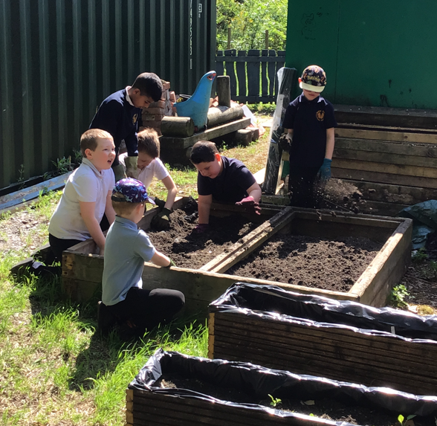
In Maths, we will be focusing on multiplication, building confidence with times tables and using them to solve a range of problems.
In English, we will be exploring five exciting stories throughout the term, including works by well-known authors such as Tom Fletcher, Roald Dahl and Dr Seuss. This will help us to develop our reading, comprehension and creative writing skills.
In our REAL Project, we are learning about “Our Amazing Bodies”, where we will discover how our bodies work and understand the importance of keeping them healthy.

We're so proud of the progress every child has made with their reading this year — let’s keep it going! Reading books and diaries will be sent home every Thursday. Please log any reading at home in their diary. If your child reads at least four times a week, they’ll earn 5 Dojo points to spend in our Dojo shop!
Homework goes home every Wednesday and is due back the following Wednesday morning. It supports your child’s learning and shouldn’t take more than 30 minutes to complete.
Children can also use Times Tables Rockstars and Bug Club at home. If you're unsure how to access these, just ask a member of the Respect Team — we're happy to help!

Spending a little time at home supporting your child with reading and maths can make a big difference. Encourage your child to read regularly and practise spelling tricky words. You could spot these words together in their reading books — or even on signs, posters and notices when you're out and about.
In Maths, practising times tables will really help build confidence with multiplication. Quick, little-and-often practice (such as chanting, games or apps) can make a big impact.

Singing Festival at De Montfort Hall – Tuesday 28th May

Schools finishes for half term at 3:15pm on Friday 22nd May and returns on Monday 1st June.

Forest School Trip – Thursday 4th June

Singclusive Choir Trip – Wednesday 10th June

The last day of term is on Friday 10th July.

Summer Term 2026
P.E. – Now with the Mainstream School
P.E. is now integrated with the mainstream school, giving our children a fantastic opportunity to develop teamwork, play skills, and build confidence alongside other pupils.
Please ensure your child comes to school in their P.E. kit on P.E. days:
- Black joggers or tracksuit bottoms
- White t-shirt
- Trainers
Outdoor Learning – Summer Term
Children will be enjoying outdoor learning this term on Thursday afternoons. As the weather warms up, please make sure your child comes to school with a sun hat and sun cream (applied before school if possible).
If you have any spare sun hats or lightweight outdoor clothing you'd be happy to donate, we’d be very grateful — just send them in with your child.
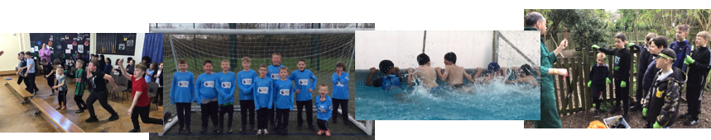

Swimming Lessons
Every child has had the opportunity to take part in swimming lessons each afternoon over the past two weeks. It has been wonderful to see how their confidence in the water has grown, as well as how independently they have been getting themselves ready before and after lessons. We have also been really impressed with the progress in their swimming skills.
Important Dates & Contact Information
Please make sure to read your child’s phase newsletter for any important dates in the diary.
As always, if you have any questions or concerns, please don’t hesitate to speak to us at the end of the day, send a message on Seesaw, or contact the school office by phone.
Thank you,
Respect Team 😊

