

Chinese New Year – Wear something that makes you feel proud, Friday 13th February
Schools finishes for half term at 3:15pm on Friday 13th February and returns on Monday 23rd February.
Football Trip – Tuesday 3rd March
World Book Day – Thursday 5th March
Think Tank Trip – Wednesday 11th March
Parents Evening – Week commencing Monday 23rd March
The last day of term is on Friday 27th March.
Consistent routines help children feel safe, calm, and ready to learn. Regular bedtimes, mealtimes, and clear morning or after-school routines can support your child’s wellbeing and concentration at school. Knowing what to expect helps reduce anxiety and allows children to focus more confidently on learning and social interactions. Developing communication skills helps children express their needs, feelings, and ideas. At home, encourage your child to use words, signs, pictures, or gestures to communicate. Give them time to respond and celebrate all attempts at communication. Sharing books, naming objects around the house, and talking about daily routines all help build understanding and confidence.

This term, our REAL project is Magnificent Machines. The children will be exploring how machines help us in everyday life, learning about a famous engineer, and discovering how vehicles work. They will design and make their own moving vehicle, developing creativity, problem-solving and practical skills. In English, we will be sharing a range of inspiring stories including The Girl Who Thought in Pictures, Going Places, Izzy Gizmo and If I Built a Car. In Maths, we will be focusing on measurement, including mass and money. The children will practise using real-life resources to support their understanding and apply these skills to everyday situations.

Spring Term 2026
Reading at home continues to be very important. Reading books and records will be sent home every Thursday, and we encourage children to read or share a book with you at least four times a week. This can be for just a few minutes and can include talking about pictures or listening to a story. Please remember to record this in their diary so your child can earn Dojo points. Homework will be sent home every Wednesday and is due back the following Wednesday morning. Homework is designed to be short and manageable and should take no more than 30 minutes in total. It can be broken down into small bursts, such as completing one question a day, if this works better for your child. Children can also practise at home using Times Tables Rockstars and Bug Club. If you need support accessing these, please speak to a member of the Respect Team.

Happy New Year – 2026!

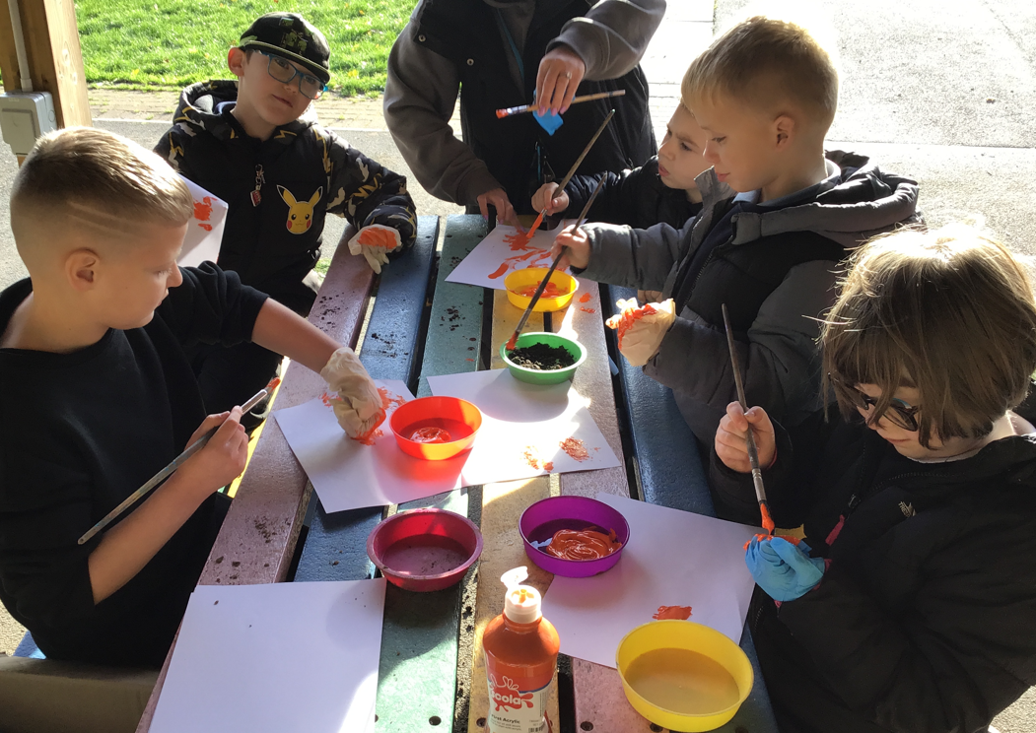

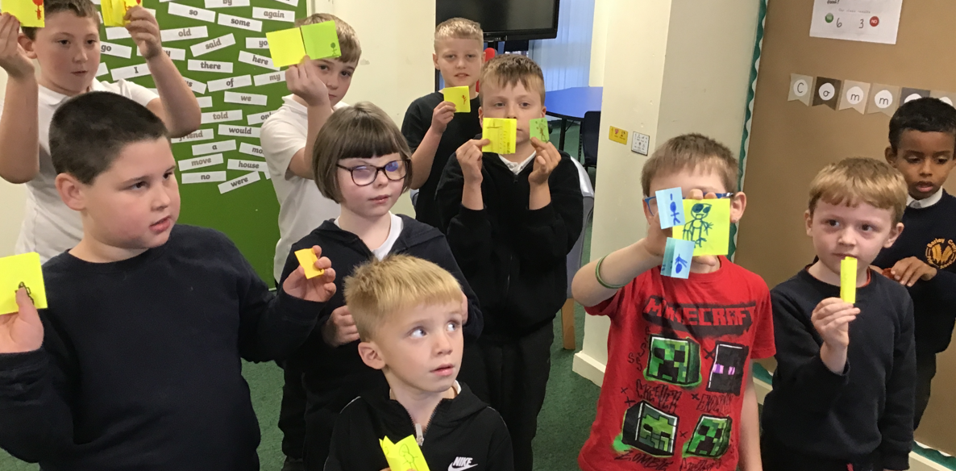
Team Respect would like to wish all our wonderful families a happy, healthy and successful term. We are really looking forward to all that lies ahead.
P.E. lessons are taught alongside a mainstream class. A timetable is displayed on the classroom door if you are unsure of your child’s session. Please ensure children come to school in their P.E. kit on their allocated day: black joggers or tracksuit bottoms, a white t-shirt and trainers.
The children will be taking part in outdoor learning on Tuesday afternoons this term. If you have any spare raincoats, wellies or outdoor clothing that you are happy to donate, we would be very grateful.
Cooking will take place on Thursday afternoons. We kindly request a contribution of £5 per term (£15 for the year) to help cover the cost of ingredients paid in cash directly to class – Thank you to those already contributed. Cooking sessions provide an excellent opportunity for children to explore their sensory needs, including touch, taste and smell, while developing independence and life skills.
Please remember to check your child’s phase newsletter for important dates and events.
As always, if you have any questions or concerns, please speak to a member of Team Respect at the end of the day, message us on Seesaw, or contact the school office.
Thank you for your continued support,
Mrs Smith, Mrs S, Mr Mills and Miss Clayton

