Our topic this half term is ‘I wonder who helps us?’ and we will be focusing on learning about all the different jobs people do that help us. We will continue with phase 1 phonic games and activities and continue to develop our mark making skills.
We will be continuing with math’s, consolidating numbers to 5 and how to use them in different ways.

In order to support the children with their transition to full time school in Reception, we would like the children to continue to enter the classroom independently and to start to take their own coats off and hang them up. Please support your child with this by dropping off to the outside door during this half term and allowing them to get used to doing this without you present.

- Enjoying stories together.

- Singing lots of nursery rhymes.

- Trying to get dressed and undressed independently including trying their zips and putting their shoes on by themselves.

- Counting to 10 consistently.

- Practice writing their name.

Trip to Manor Farm
Monday 15th June
More information to follow soon.

Summer Term 2026
We know you have all now found out your child’s school place for September. We are excited that everyone will be joining our Reception class in September, we will begin to support their transition to make sure it is as smooth as possible. Mrs Brewster will be in touch with you all very soon with what happens next.

All the children have been really enjoying our Forest School sessions. They have taken on board the session rules and follow them well. They have enjoyed exploring our new Forest School area independently and we are very proud of how confident they all are!

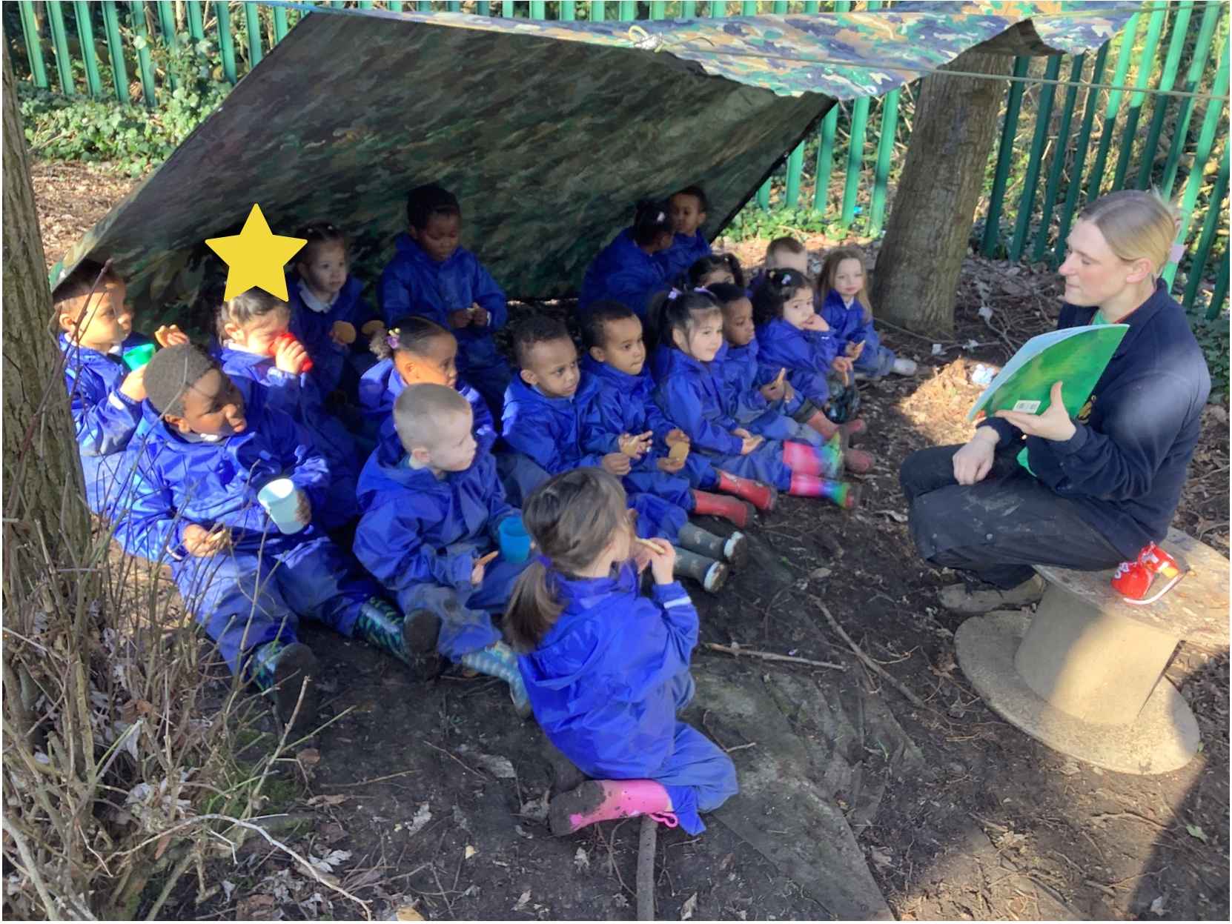

We look forward to another fun term in Nursery !



