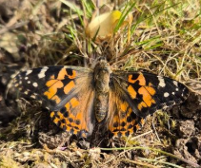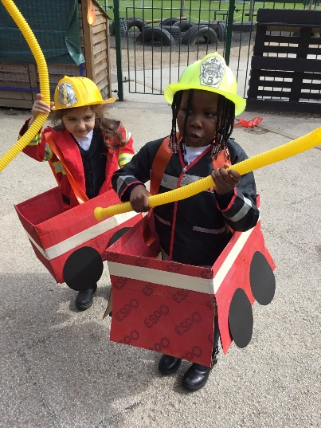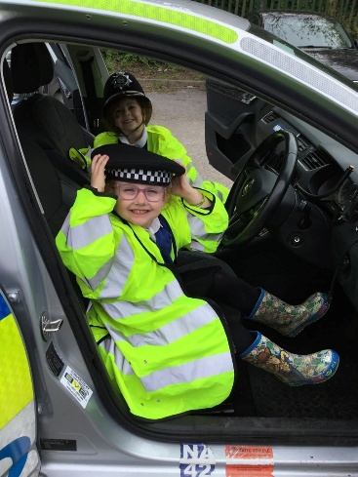

We will be learning about our local community and the people who help us, looking at shops and community buildings around Beaumont Leys.

Children will continue to learn how to brush their teeth at school, please continue to support them with this at home.

We will also start to talk more about year 1 to support the children with their transition. By talking to the children in general conversations, we hope to build up an excitement for the next part of their school journey.

- Writing their full names independently. Please practice writing in lower case letters at home using the correct letter formation

- Reading their reading book at least 3 times a week together

- Practice tying their own shoe laces if they have laced shoes.

- Counting all the way to 50!

Trip:
Monday 15th June.
Trip to Manor Farm.
Further information on this trip is to follow

Sports Day:
Thursday 2nd July 2:00pm.
This will be on the school field weather permitting.
More information to follow nearer the time.

Our topic this half term is ‘I wonder who helps us?’ We will be learning all about people who help us and what they do. We will look at equipment they use, uniform that they wear and vehicles they drive. When looking at vehicles, we will be looking at how they have changed over the years. We will be continuing to teach phase 3 phonics for most children, giving those children that are still finding phonics a little tricky a little extra support to continue their learning to begin reading and writing.

Summer Term 2026

Last half term we enjoyed looking for signs of spring all around us. We saw tadpoles emerge from frog spawn and turn into little froglets and learnt that caterpillars turn into butterflies! We are definitely in Spring now.

As we move into our Summer term, as well as learning about People Who Help us, we will be learning all about farm animals, using our visit to the farm and the story ‘Little Red Hen’ to help us.

To finish our fun filled Reception year, we will enjoy learning all about the Seaside and designing, making (and eating!) our very own ice-cream sundaes!

Please remember to send in your child’s book bag every day. As the days get a little busier towards the end of the academic year, we sometimes need to change the days we visit the library and change reading books so it helps to have them in school every day.
If your child no longer has the school bookbag they were given when they started school, please ask at the office for information on purchasing a new one. It really does help the children take responsibility for their school belongings.

Thankyou all for your continued support, ensuring your child’s first year at school has been a positive one.

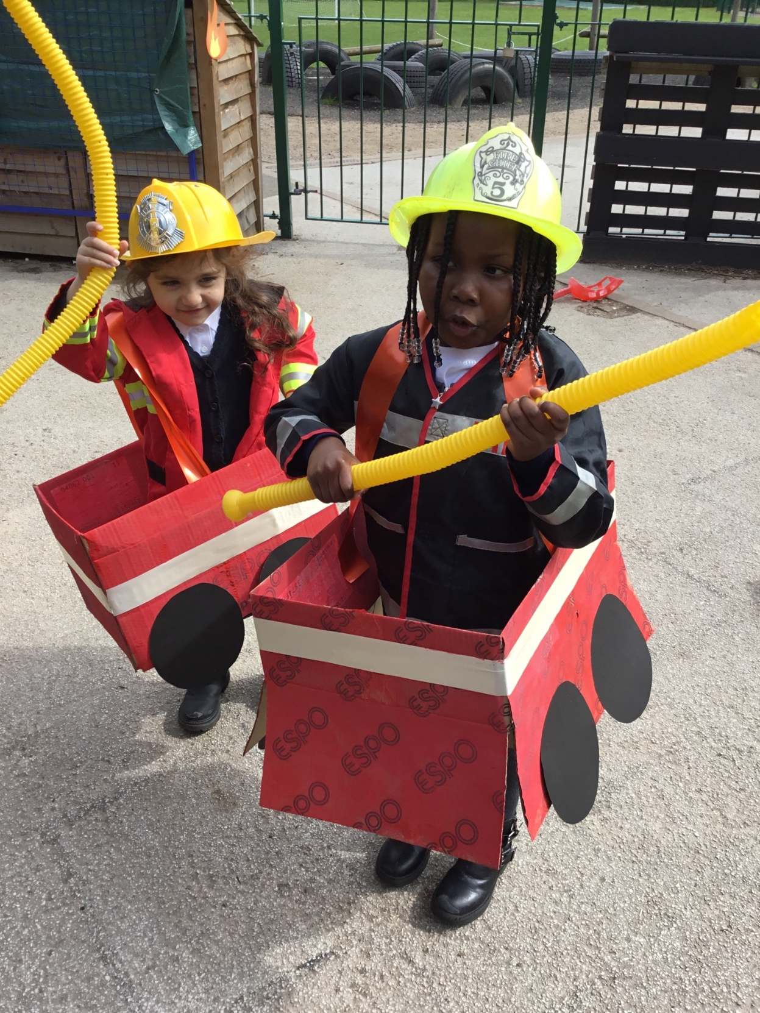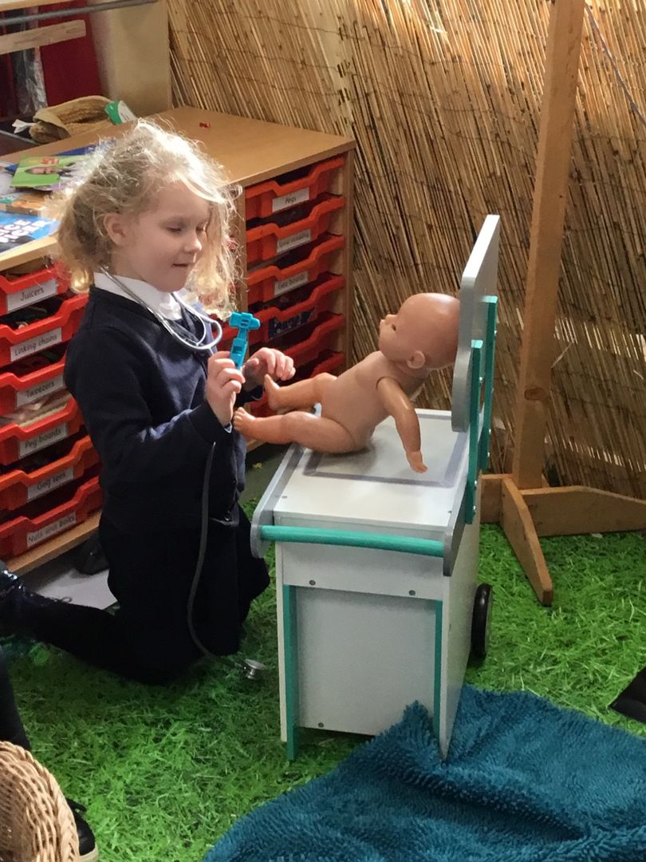

We are looking forward to another exciting term

