Please ensure your child continues to bring their bookbag to school each day. This is so that they can begin to take responsibility for their own belongings by bringing their super creations home for you and any important letters we give them.

They are also welcome to bring in a water bottle and fruit is available for them during their session. Please send some spare clothes in a bag in case of any wet or messy play accidents.
- Enjoying stories together.

- Singing lots of nursery rhymes.

- Trying to get dressed and undressed independently including trying their zips and shoes by themselves.

- Counting to 10 consistently.

Our topic this half term is ‘I wonder what is out there?’ and we will be focusing on learning about hot and cold countries. We will continue with phase 1 phonic games and activities and continue to develop our mark making skills. We will be beginning to look at saying our numbers in the correct order and counting objects to 5. We are excited to be starting to have more of a focus on a story and beginning to retell familiar stories ourselves.
Forest School every Wednesday a.m.

You can support the children to prepare for this by practicing with them to help them independently take off their shoes and to put them back on again.

Spring Term 2026
We are very proud of how well all the children have settled into school during their first full term

As we move forward to our spring term, please begin to encourage your child to enter school independently to help them continue to grow in confidence. As you drop them off at the classroom door, they will be supported by staff in the classroom to get ready for their school day.

Please ensure your child does not bring any toys to school as they could get lost or broken,

Please ensure ALL your child’s clothing is labelled with their name. Pen is ok for this but do check each wash in case it needs writing again. This helps staff get the correct clothing to the right child if something gets misplaced.

We look forward to another fun term in Nursery.

Miss Miller and the EYFS team

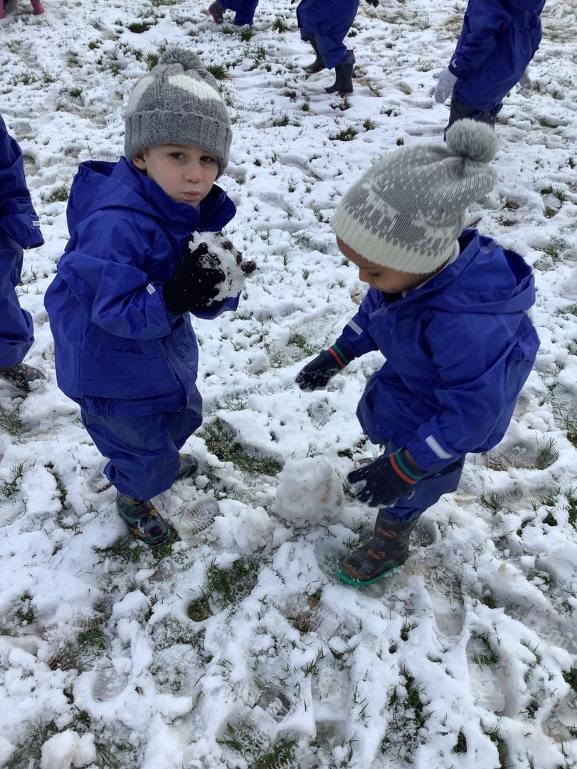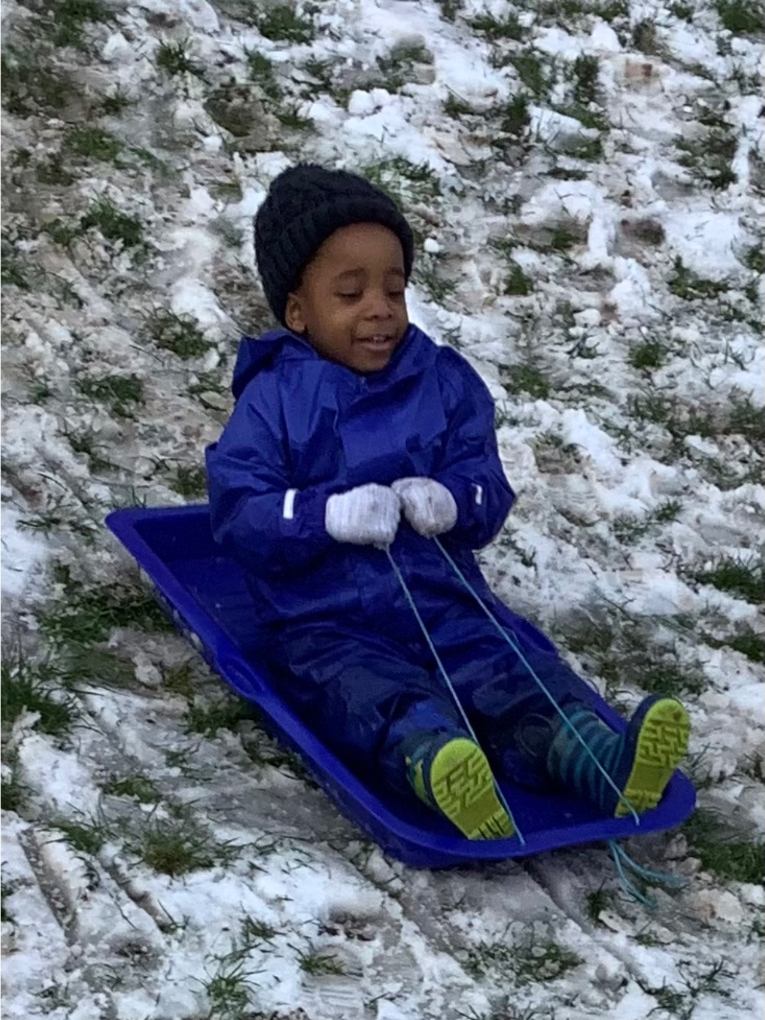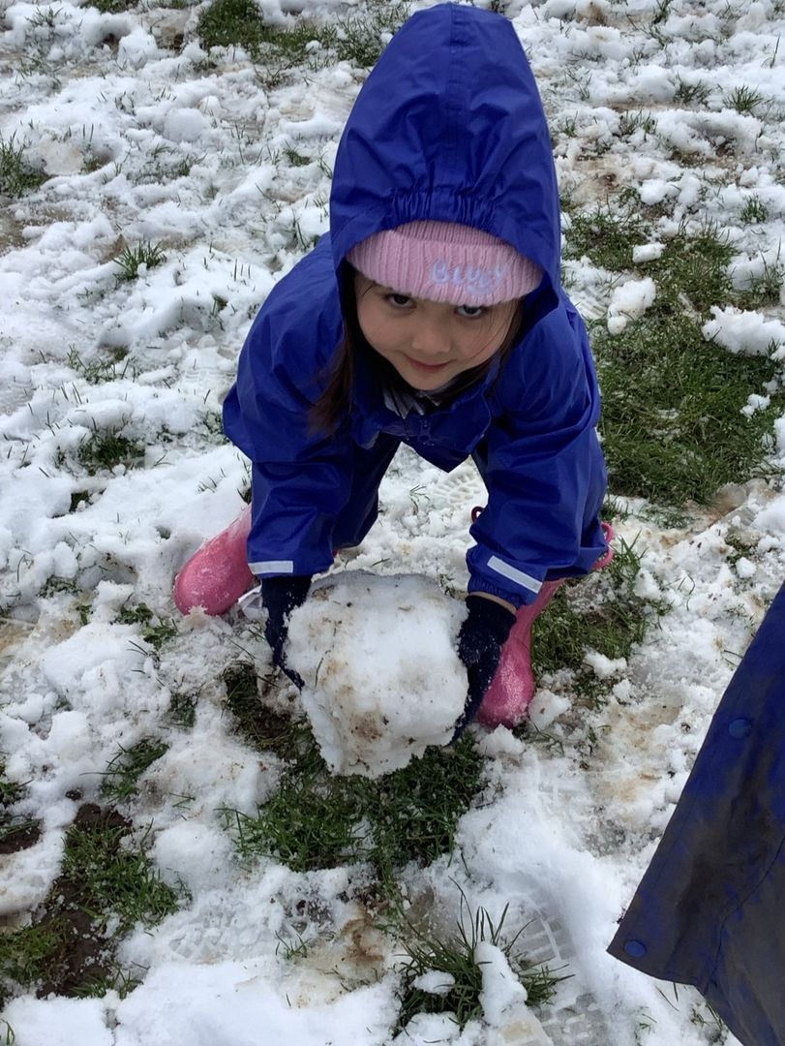

We had a super time in the snow last week!

