=
As we welcome all our new Nursery children, we will be supporting them to enter school with a smile each day, settle into school routines and begin to form friendships with their new peers.
Please ensure your child brings their book bag to school each day. This is so that they can begin to take responsibility for their own belongings by bringing their super creations home for you and any important letters we give them.
They are also welcome to bring in a water bottle and fruit is available for them during their session. Please send some spare clothes in a bag in case of any wet or messy play
accidents.

Our topic this half term is ‘I wonder what makes me marvelous’ and we will be focusing on who we are and what we look like as well as things we like/dislike. We will begin some phase 1 phonic games and activities and also begin to explore making marks in different ways. We will be beginning to look at saying our numbers in the correct order and counting objects to 5.
- Encouraging them to dress and undress independently.
- Supporting them to learn how to wash their hands and use the toilet.
- To begin to drink from an open cup.
- To sing simple nursery rhymes together.
- To share stories and talk about what happens in them.

Forest School day: Wednesdays.

Half term: Monday 20th Oct to Fri 25th.

Parents meetings: November 17th and 19th. More information to follow.

PLEASE NOTE: Nursery children will NOT be attending PE lessons this term so do not need to wear PE kit to school.

Autumn Term 2025
We are very much looking forward to welcoming you and your child to our Nursery Class. We would like to thank you all for making us feel very welcome during our home visits. It has been lovely to see you and your child in your home environment.

We have been busy getting the classroom and outdoor learning space ready for the new academic year and can’t wait to see what adventures we will have together.

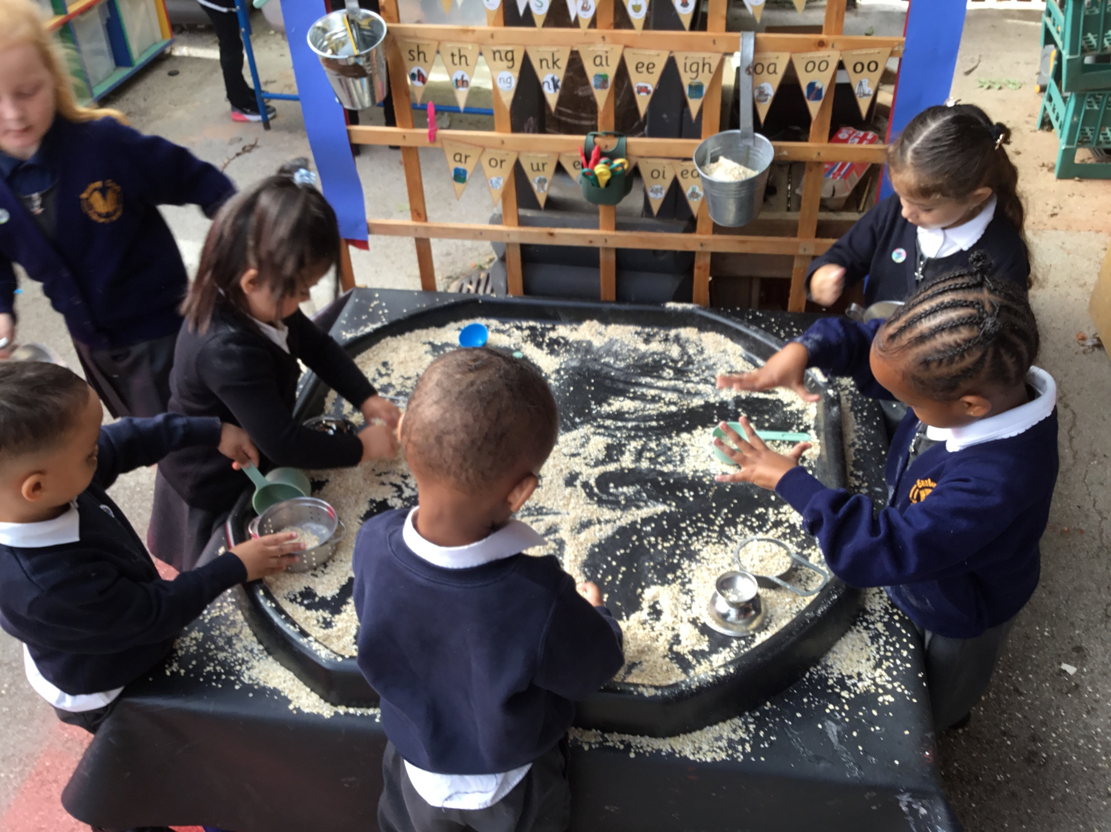

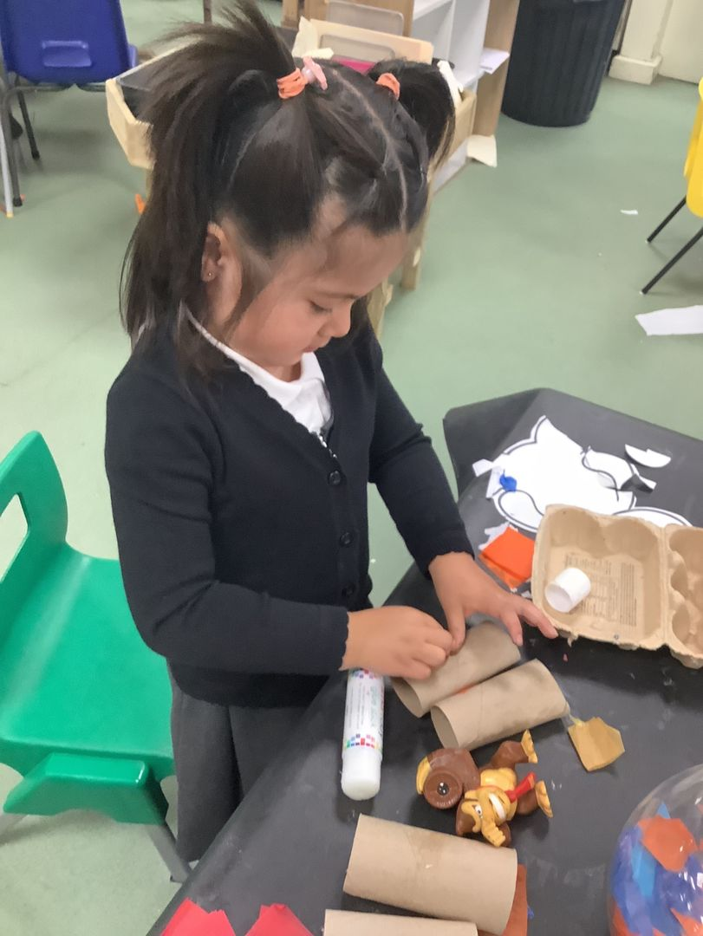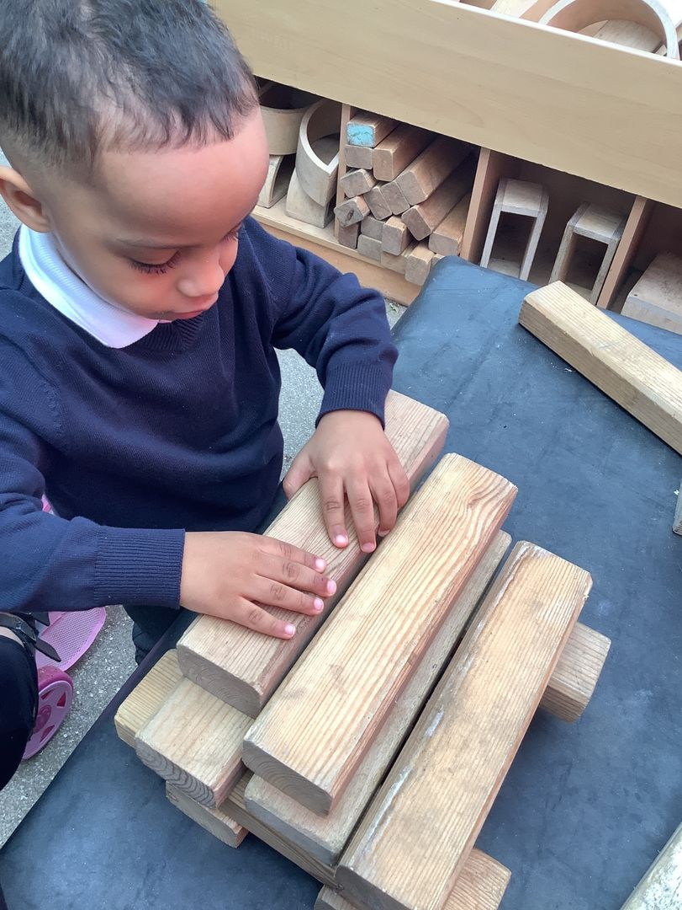

Looking forward to a fun filled term.

Miss Miller and EYFS Team

