Please ensure your child has their school book bag and brings it to school each day. This is so that they can begin to take responsibility for their own belongings by bringing their super creations home for you and any important letters we give them. It also gets them in the habit of using it ready for when they begin to bring a reading book home.
Please send your child with a water bottle each day. Also send a bag with spare clothes in incase they get wet or messy during the day.
All children have access to fruit and water during the day. If they wish to bring in their own snack, it must be 1 whole piece of fruit ( no grapes etc).
- Encouraging them to dress and undress independently.
- Supporting them to learn how to wash their hands and use the toilet.
- Drink carefully from an open cup. We will also be encouraging those who have a hot lunch to use a knife and fork so this skill can also be supported at home.
- We will be beginning to write our names too so have a little practice each day to help them. form their letters.
Our topic this half term is ‘I wonder what makes me marvelous’ and we will be focusing on who we are and what we look like as well as things we like/dislike. We will be begin to teach phase 2 phonics, focusing on a sound per day and supporting the children to use these sounds as they begin to read and write some simple CVC words. We will be introducing number and focusing on numbers to 5 and learning to subitise. We will be learning to make meaningful marks and begin to write our names.
PE day: Thursday. Please send your child to school in their PE kit. Black tracksuit bottoms/shorts, white T-shirt and trainers or plimsoles.

Forest School: Wednesday . This will be alternate Wednesdays with half of the class going each week. Look out for when it is your childs week on Seesaw.

Parents meetings: November 17th and 19th. More information to follow.

Autumn Term 2025
For those of you new to Barley Croft, we would like to thank you all for making us feel very welcome during our home visits. It has been lovely to see you and your child in your home environment.

We have been working hard on creating a welcoming and inviting learning space where we hope the children will be able to fully immerse themselves in play-based learning opportunities. We have given our outdoor spaces a little makeover too and this will continue to evolve over the coming weeks.

You should all be very proud – all the children have come into school with such confidence and have begun to explore the classroom and the activities on offer. They are all super keen to learn and we are excited for a fun filled first half term!

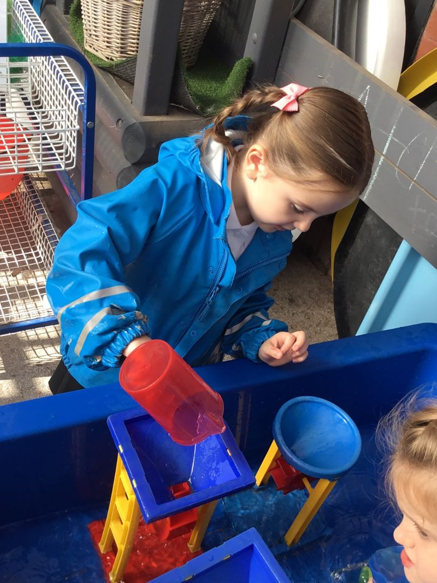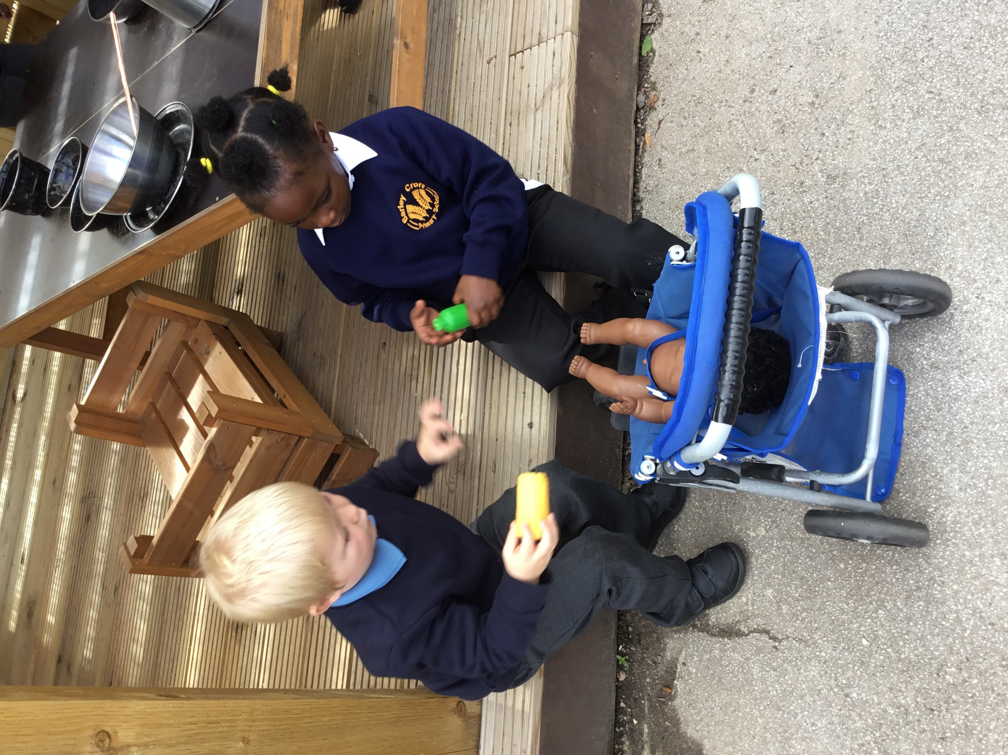

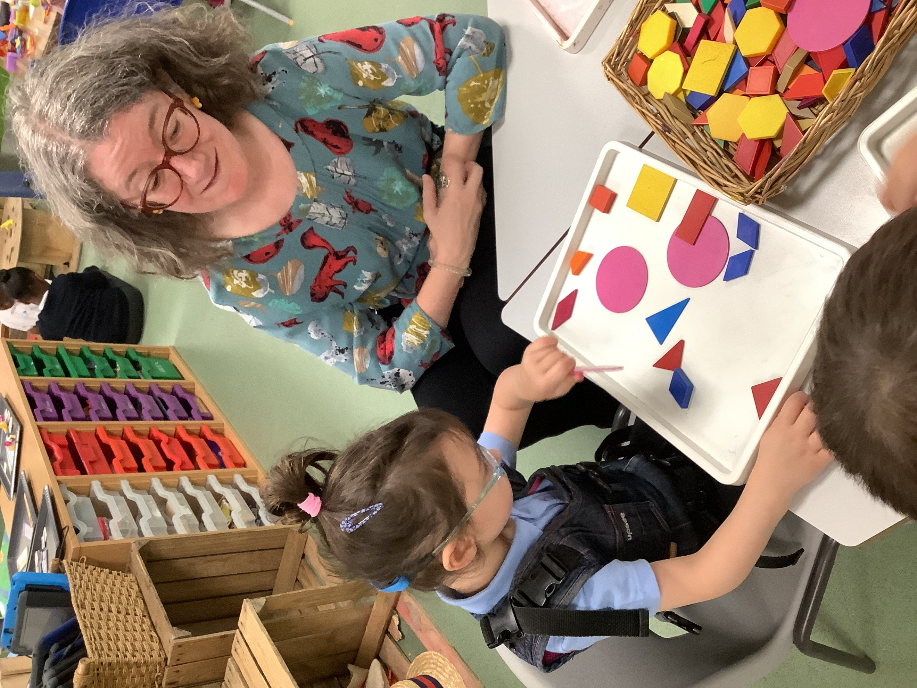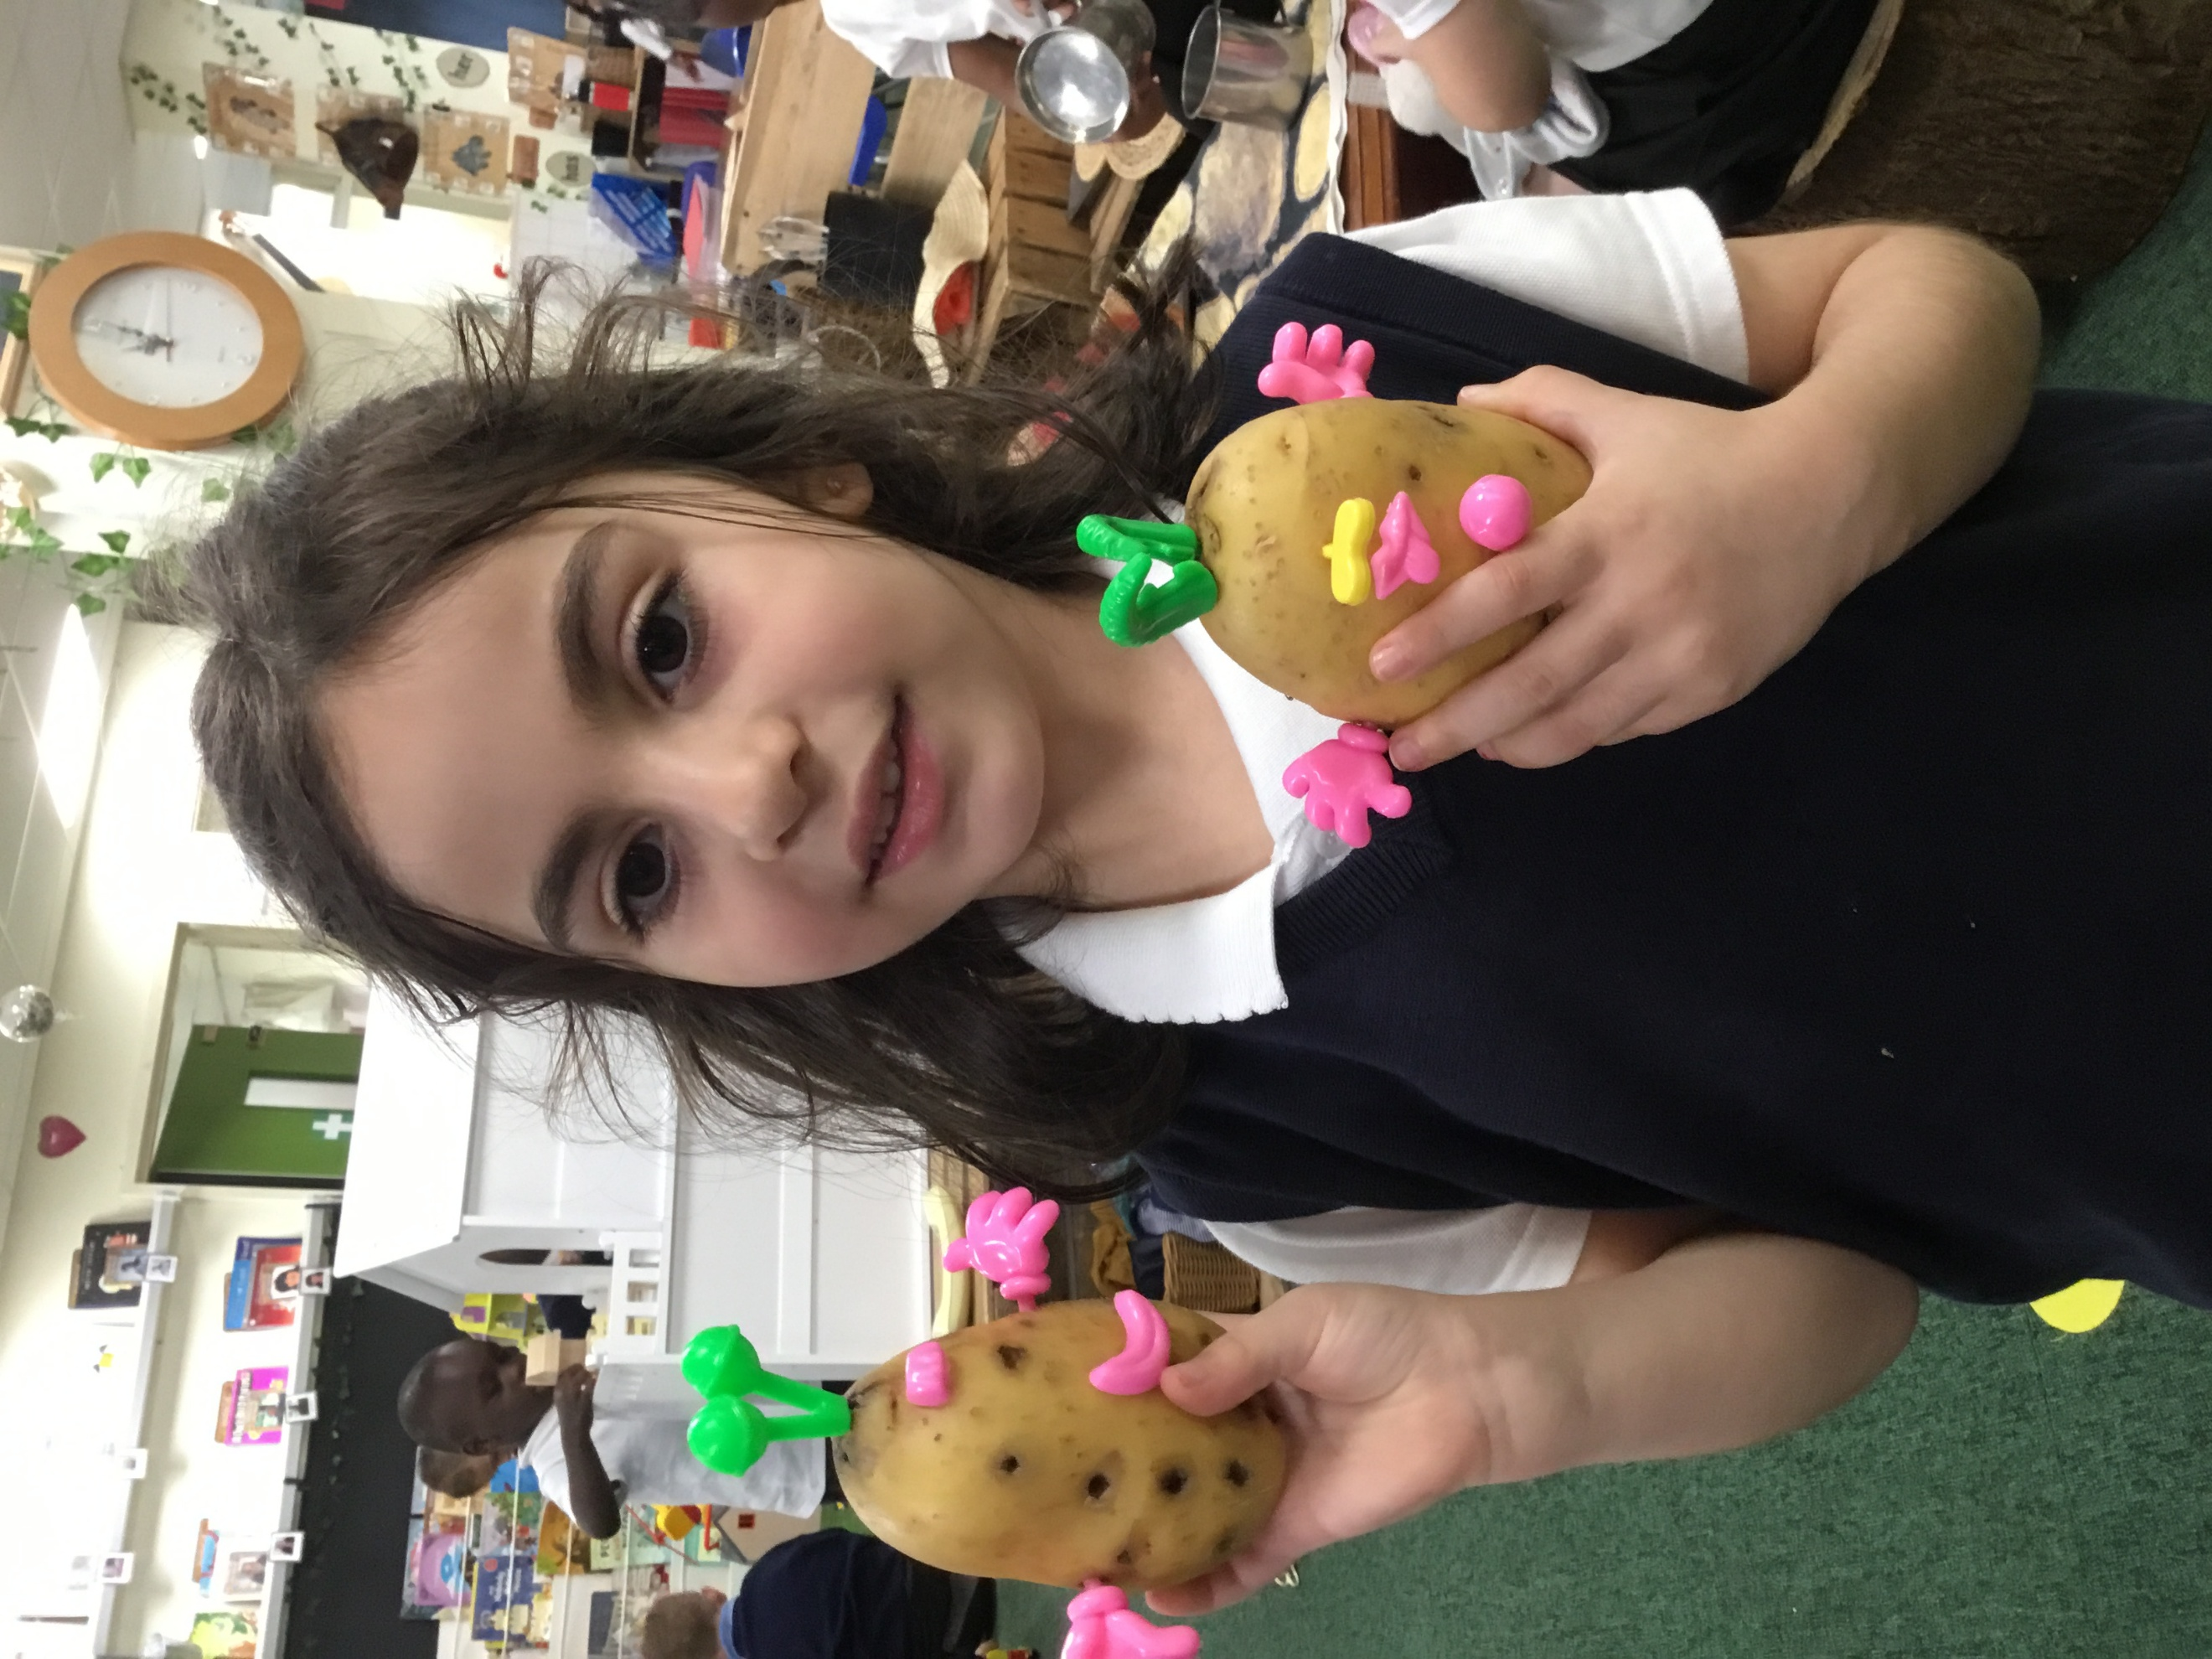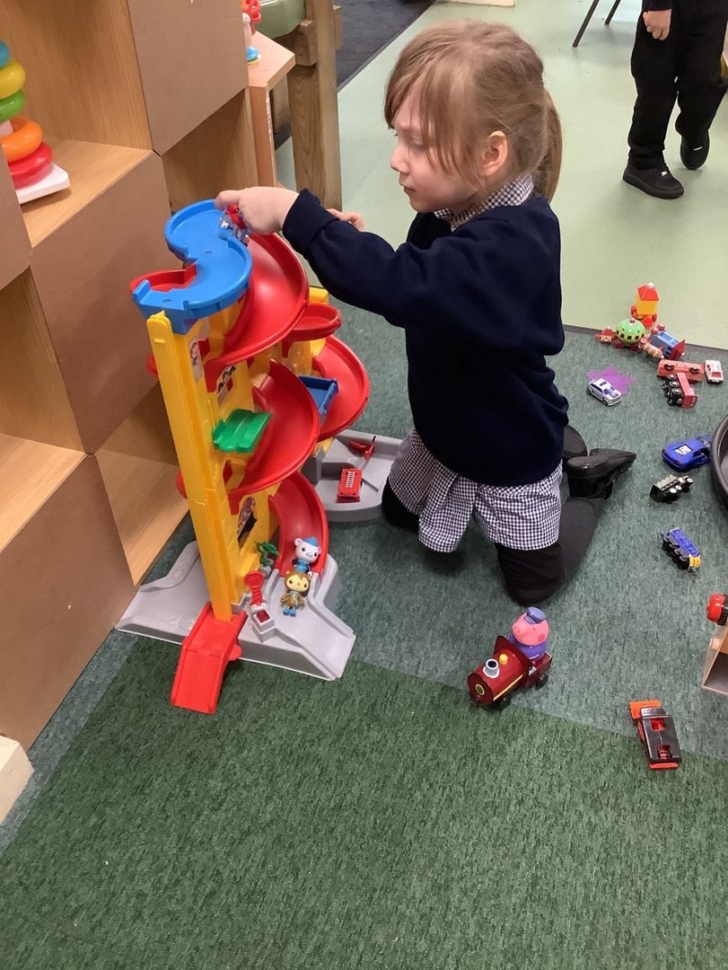

Mrs Brewster and the EYFS Team

