`
How did we end up here?
- Trail around Leicester using our geographical skills
- Local study King Richard III
- Blitz
- Study of Anne Frank
- 111

10th September – Trip Bradgate Park
9th October – Trip to Bosworth Battlefield
19th-23rd October – Half term
2nd-6th November – Year 6 Into University
24th and 25th November Parents evening

- DT building Ancient Egyptian houses using Tinkercad
- Ancient Egyptians
- Artist – Stephen Wiltshire


Homework expectations
Your child needs to bring their book bag to school every day. It should contain their reading book and reading diary. All pupils are expected to read a minimum of 4 times a week and this needs to be recorded in their homework diary and signed by an adult. We will also expecting children to learn their timetables via TT rockstar and learn their weekly spellings.
We will also be setting a family homework challenge related to our real project - more information about this is coming soon.

School gates open at 8:35 am and your child should be in class by 8.45

P.E. kit needs to be worn from home on the day your child has P.E a gentle reminder the PE uniform is : Plain black , blue or grey jogging bottoms or shorts and plain white or black t-shirt. A change of shoes is also necessary. No logos or football kits should be worn.

Autumn Term 2026
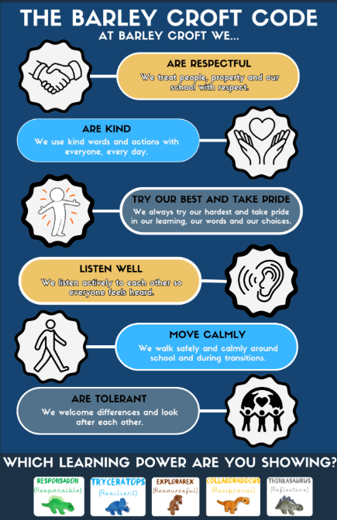

A Fantastic First Week in Year 5/6!

Year 5/6 have had a fantastic first week, settling into their new routines and getting off to a brilliant start. We have kicked off the year by exploring our Learning Powers and thinking about how these can help us to grow our brains, overcome challenges and become lifelong learners.We have explored what it means to be Reciprocal, Resilient, Resourceful, Reflective and Responsible, and considered how we can use these important qualities in our learning every day.
We have also spent some time thinking about what makes each of us special and unique. We chose some of our best features and qualities and then wrote about what makes us proud to be ourselves. It has been lovely to see the children celebrating their own individuality and recognising the wonderful qualities they each bring to our Year 5/6 community. What a fantastic start to the year! We are excited to see what the rest of the year has in store.

Reminders
- All children need to be wearing school uniform including their PE kit.
- No mobile phones are allowed in school. However, if this is necessary a teacher needs to be informed and the phone handed to the office.
- Children should not be using social media platform that is not age appropriate for them and we ask all parents to check their child’s phone regularly. This is to ensure we are keeping them safe.
- Water bottles should be taken home at the end of the day to be washed and ready for the next day.
We look forward to a great year ahead of us filled with lots of learning and fun.

