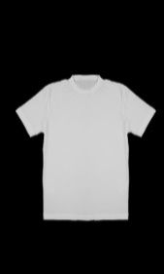
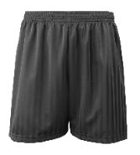
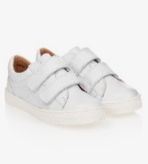
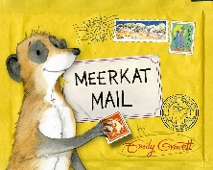
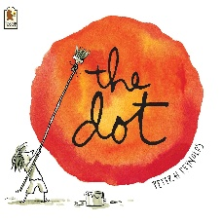
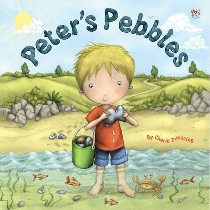
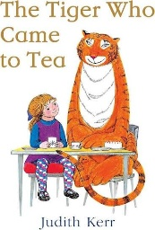
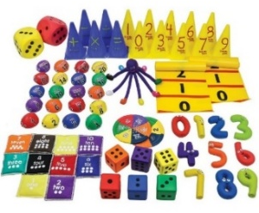
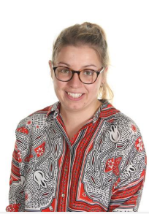
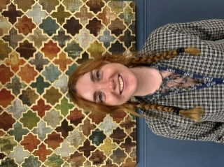

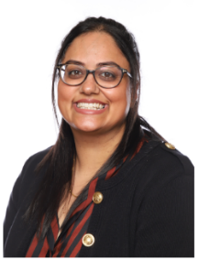
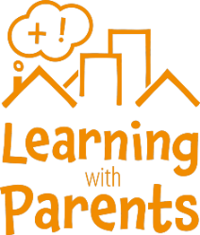
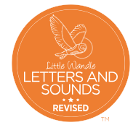
Wednesday 9th September
Whole School ‘Belong’ Day
Tuesday 6th October
3pm book look – you are invited into classrooms to see our environments and look at our books so far this year.
Wednesday 14th October
Year 1 and Year 2 trip to Twycross Zoo
Thursday 15th October
Wear something that makes you feel proud to celebrate Diwali.
Friday 16th October
School closed for children – staff training day
w/c Monday 19th October
Half Term
Tuesday 24th & Wednesday 25th November
Parents’ Evenings
Thursday 10th December
Winter Disco
Thursday 17th December
Wear something that makes you feel proud to celebrate Christmas.

Please see the Knowledge Organiser for key learning and vocabulary linked to our Project.
I wonder who lives where?
Subjects we will be learning are:
- Geography – seasonal and weather patterns in the United Kingdom
- Geography – areas of the world in relation to the Equator and the North & South Poles
- Art – self-portrait in pointillism style, inspired by the artist: Roy Lichenstein
- Science – Animals and their Habitats

Reading
We expect children to read at home daily.
All books will be changed weekly on a Friday. Please look after school books and return them every week so your child’s book can be changed.
Maths
Please encourage your child to practise number formation, number facts and times tables (Y2) every day.
Homework
Weekly Maths and English homework is set for pupils to complete at home on our online learning platform, Seesaw, every Friday. If you require a new Seesaw QR code, or if you would prefer paper homework, please speak to your child’s class teacher.

Autumn Term 2026
I wonder what makes me marvellous?
Subjects we will be learning are:
- Art – Self Portraits
- Geography – Where am I from?
- History – Changes within living memory
- Science – Human body, Living things & Staying healthy
Please encourage your children to remember the ‘Learning Powers’ at school and home. Look out for certificates coming home for super learning!

PE
We expect to come to school wearing their Barley Croft PE kit on the days when their class has PE; they will not get changed at school. We expect children to be wearing the Barley Croft PE kit:
• Plain black/navy shorts or plain black/navy jogging bottoms • Plain white T-shirt (a white PE T-shirt with the Barley Croft logo can be purchased from the school office) • White, black or blue trainers (not high-tops/boots).
> Honesty class (Mr Easton - Y2) – Friday
> Kindness class (Mrs Smith & Mrs Tobin – Y1) – Tuesday
> Courage class (Miss Banning – Y1/2) – Thursday
For our first Writing unit this term, we are exploring the lovely book: The Colour Monster. After that, we will be using the fantastic story, The Dot, inspired by our Art learning. Later in the half term, we will read and write using the famous book, The Tiger who Came to Tea, by Judith Kerr.
Then, our fiction writing will be based on Peter’s Pebbles, linked to our Science lessons about different animals. Non-Fiction writing will explore Meerkat Mail, where children write their own fact file about a chosen animal.
In our Maths lessons this term, we will be learning…
Year 1:
Numbers to 10
Part Whole models within 10
Addition and subtraction within 10
2D and 3D shapes
Year 2:
Numbers to 100
Addition & Subtraction
Properties of Shape
Phonics – Learning to Read
We use Little Wandle for Phonics – teaching pupils to read. Children are grouped based on individual assessments to ensure they are learning at an appropriate stage. Reading books we send home are carefully matched to children’s Phonics ability. Parent resources to support Phonics at home can be found here: https://www.littlewandlelettersandsounds.org.uk/resources/for-parents/

Meet the teaching staff in the Year 1/2 team this term:

Miss Banning Mr Easton Mrs Smith Mrs Tobin

Some of the additional, amazing adults in our phase this term are:
Miss Bliss, Mrs Miller, Miss Andrews, Miss Brooks, Miss Dodman, Miss Shackleton,
Mrs Huntley and Miss Adesina.

We would love you to log your child’s daily reading at home on the ‘Learning with Parents’ website.
A link to access this will be sent early in the Autumn Term.
Please see your child’s class teacher if you are having trouble accessing the website.

