
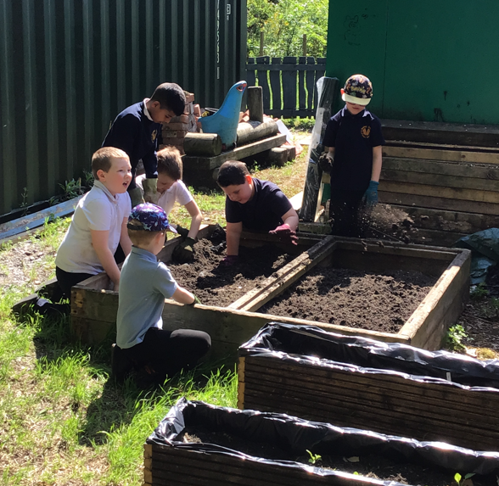
In Maths, we will be focusing on number and place value.
In English, we will be exploring lots of exciting stories throughout the term. Our first story will be School Is Wherever I Am by Ellie Peterson. These stories will help us to develop our creative writing skills, as well as our grammar and punctuation.
In our REAL Project, we will be learning about Ancient Egypt – Lost Worlds, where we will explore and discover more about this fascinating civilisation.

Schools finishes for half term at 3:15pm on Friday 16th October and returns on Monday 26th October.

The last day of term is on Thursday 17th December.

Return to school Tuesday 5th January 2027.
Homework will be sent home every Monday and should be returned the following Monday morning. Activities will support your child’s English and Maths learning and should be a manageable way to practise skills at home.
Children can also access Times Tables Rockstars, Numbots and Bug Club to support their reading and Maths skills. Login details can be found inside their homework book. Completing homework will also earn your child House points!
Reading books will be sent home and changed every Friday. Please make sure your child brings their reading book into school every day, so they can enjoy reading both at school and at home.

Reading and handwriting will be two important areas of focus for us this term. Reading together at home is a great way to develop your child’s confidence and enjoyment of books. Talking about characters, asking questions and sharing favourite parts of a story can all help to develop their understanding.We will also be working on developing clear, fluent handwriting. At home, encouraging your child to take their time and practise forming letters correctly can really support their progress. Any opportunity to write for a purpose — whether it’s a note, a list or a short message — will help them to develop their confidence and pride in their work.

Autumn Term 2026
P.E. with the Mainstream School
We’re really pleased that our children will continue to enjoy P.E. alongside pupils from the mainstream school. These sessions provide a fantastic opportunity to have fun, stay active and develop important skills such as teamwork, confidence and playing alongside others.
Please make sure your child comes to school wearing their P.E. kit on their allocated P.E. day:
- Black joggers or tracksuit bottoms
- White T-shirt
- Trainers

Outdoor Learning
We’re looking forward to another term of exploring, discovering and learning outdoors! Outdoor Learning will take place on Monday afternoons, giving the children lots of opportunities to enjoy being active and curious in the fresh air.
As the weather can be unpredictable, please make sure your child comes to school with suitable warm clothing and appropriate footwear. Wellies are always a great option and can be left at school if that’s easier.
Finally, if you have any spare or outgrown outdoor clothing that could be given a new home, we would be incredibly grateful for any donations. Simply send any suitable items in with your child — thank you for your support!
Uniform
Please ensure your child wears the correct school uniform every day. If you are unsure about any uniform requirements, please speak to a member of staff or check the school website.
Important Dates & Keeping in Touch
Please take a moment to read your child’s phase newsletter, where you’ll find all the key dates and events coming up this term.As always, we really value working together with you. If you have any questions, worries or anything you’d like to share, please don’t hesitate to speak to us at the end of the day, send us a message on Seesaw, or contact the school office by phone. We’re always happy to help!
Thank you, as always, for your continued support. We’re looking forward to a happy, busy and exciting term ahead!
The Respect Team 🌟

